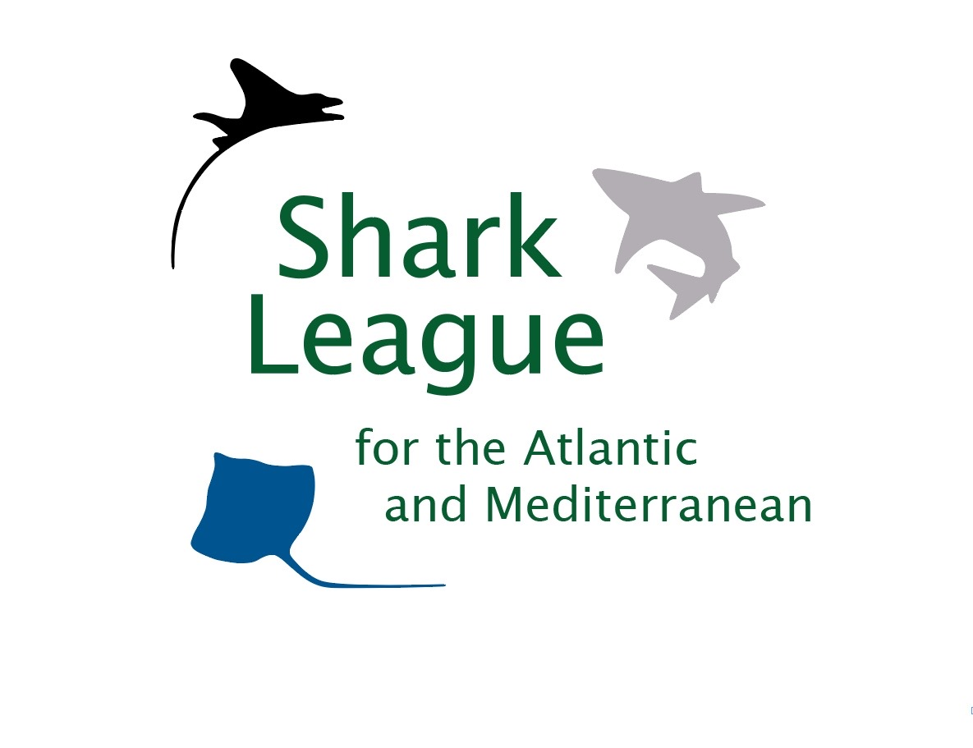
PRESS RELEASE

Canada Steps Up with Bid to Save Endangered Atlantic Mako Sharks
NGOs herald proposal for international science-based fishing limits, urge US & EU to get on board

Halifax, Nova Scotia, October 16, 2020. Endangered Atlantic shortfin mako sharks are set to take center stage in the 2020 deliberations of the International Commission for Conservation of Atlantic Tunas (ICCAT), with Canada today proposing science-based catch limits that include a complete retention ban to protect the seriously overfished North Atlantic population. Negotiations kick off next week against a backdrop of COVID-19 related mako management delays, continued overfishing by European vessels, and exceptionally lenient and complex counterproposals from the United States and European Union.

“We applaud the Canadian government for continuing to lead the fight to protect one of the Atlantic’s most vulnerable and threatened sharks, the shortfin mako,” said Shannon Arnold, Marine Program Coordinator for Ecology Action Centre. “We now look to other ICCAT Parties across the Atlantic to lend their support to this sound and urgently needed proposal, and to prioritize its adoption in the coming weeks. Such action can finally put the exceptionally imperiled Atlantic mako populations on the road to sustainability and serve as a model for the rest of world.”

Shortfin makos are particularly valuable sharks, sought for meat, fins, and sport. Slow growth makes them exceptionally vulnerable to overfishing. Makos are fished by many nations around the globe yet not subject to international fishing quotas. ICCAT scientists have reported serious North Atlantic shortfin mako declines and have recommended a ban on retention, in addition to other measures, since 2017. COVID-19 has further delayed mako management but has not stopped mako overfishing. Recent landings by EU vessels alone are triple the levels associated with population rebuilding. Population recovery will likely take ~50 years, even if mako fishing stops.

At the 2019 ICCAT meeting, Senegal and 14 other countries joined Canada in urging international adoption of scientific advice for makos. Counterproposals from the US and EU (that strayed significantly from scientific advice) prevented consensus.

“It is continually distressing that the EU and US, once shark conservation champions themselves, are the primary obstacles to addressing one of the world’s clearest and most solvable shark overfishing crises,” said Ali Hood, Director of Conservation for the Shark Trust. “Concerted action across the Atlantic is urgently needed to prevent collapse of this highly migratory species. Yet the US and EU have been choosing short-term economic interests of a few over those of a much broader array of stakeholders that rely on long-term health of the marine ecosystem. The US insists on exceptions, including for intentionally killing this Endangered species, while the EU is still fighting to allow their unparalleled, unsustainable landings to continue. Instead, they can and should lessen future ecological and economic disruption by changing course and following Canada’s lead toward protecting these shared populations, before it’s too late.”
Global concern over mako shark depletion was recognized through a 2019 listing on Appendix II of the Convention on International Trade in Endangered Species (CITES), as proposed by 27 countries and the EU. CITES Parties -- including all ICCAT Parties -- are required to ensure that mako exports are sourced from legal, sustainable fisheries.
Media contacts: Shannon Arnold, email: sarnold@ecologyaction.ca, +19023294668; Patricia Roy: patricia@communicationsinc.co.uk; +34 696 905 907.
Patricia Roy: patricia@communicationsinc.co.uk; +34 696 905 907.

Notes to Editors: Ecology Action Centre promotes sustainable, ocean-based livelihoods, and marine conservation in Canada and internationally. The Shark Trust is a UK charity working to safeguard the future of sharks through positive change. Shark Advocates International is a project of The Ocean Foundation dedicated to securing science-based policies for sharks and rays. Project AWARE is a global movement for ocean protection powered by a community of adventurers. These groups, with support from the Shark Conservation Fund, formed the Shark League to advance responsible regional shark and ray conservation policies.

The Canadian mako proposal includes science-based fishing limits for North and South Atlantic shortfin mako populations. The US proposal covers only the North Atlantic and allows exceptions to a retention ban that do not align with scientific advice.
Due to COVID-19, ICCAT’s 2020 negotiations will be limited to a few priority issues (including mako limits) and conducted online. Parties will express views and attempt to achieve consensus through email correspondence coordinated by committee chairs and the ICCAT Secretariat.
The shortfin mako shark is classified as Endangered on the IUCN Red List.
ICCAT is responsible for the conservation of tunas and tuna-like species in the Atlantic Ocean and adjacent seas. ICCAT has 53 Contracting Parties. In 2019, ICCAT scientists updated the status of Atlantic shortfin makos and estimated that cutting annual catches (including dead discards) to ~300t would give this slow-growing population a 60% chance of rebuilding in 50 years.
Retention bans can be effective in significantly reducing shortfin mako mortality as post-release survival can be as high as 77%.
The 2019 ICCAT proposal from Canada and Senegal for science-based mako limits was supported by Gambia, Gabon, Panama, Liberia, Guatemala, Angola, El Salvador, Egypt Norway, Guinea Bissau, Uruguay, Japan, China, and Taiwan.
Shortfin makos ranked first among 20 pelagic shark stocks for vulnerability to ICCAT fisheries based on Euclidean distance and third overall in an Ecological Risk Assessment for sharks conducted by ICCAT scientists in 2012.
Countries reporting 2019 catches of North Atlantic makos (Isurus oxyrinchus) include (in order of magnitude): EU (Spain and Portugal), Morocco, Canada, US, Senegal, Venezuela, Japan, Korea, Belize, Mexico, Mauritania, and Trinidad & Tobago. EU fishing vessels are responsible for 64% of North Atlantic shortfin mako catches reporting for 2019.

Conservationists have compared the global shark conservation rhetoric to reality and recommend actions for improvement.

