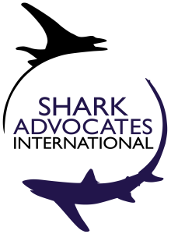
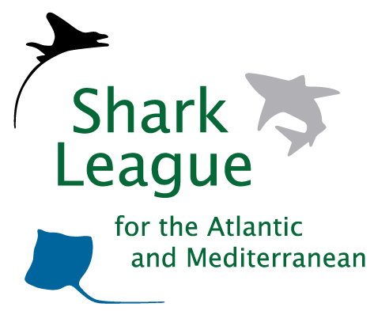
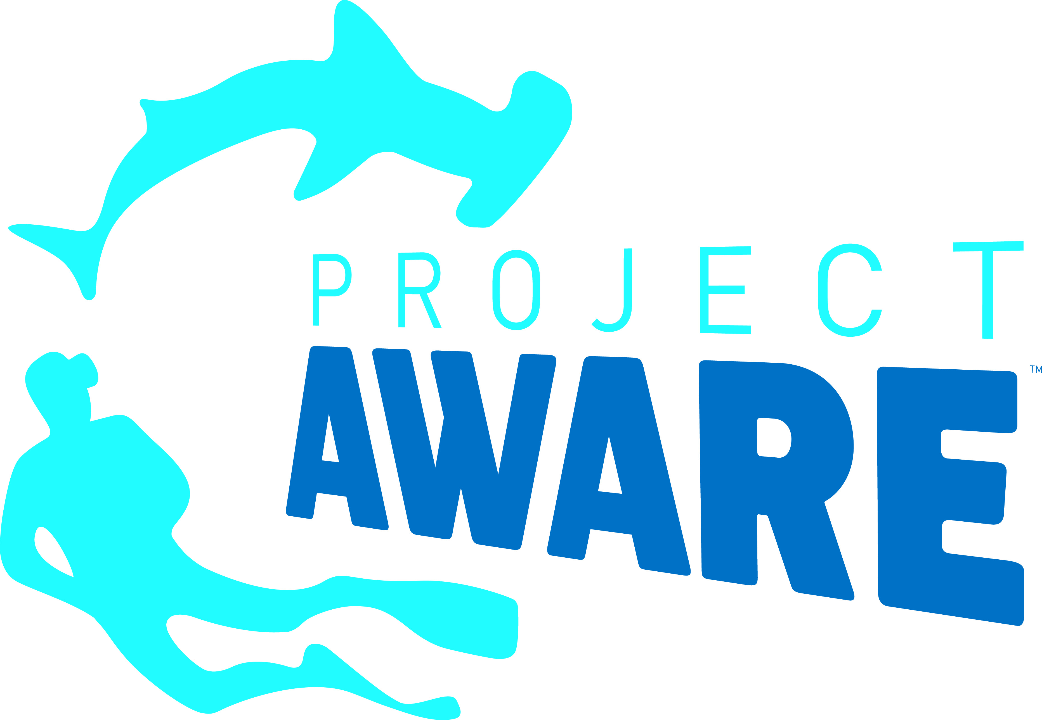
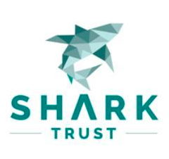
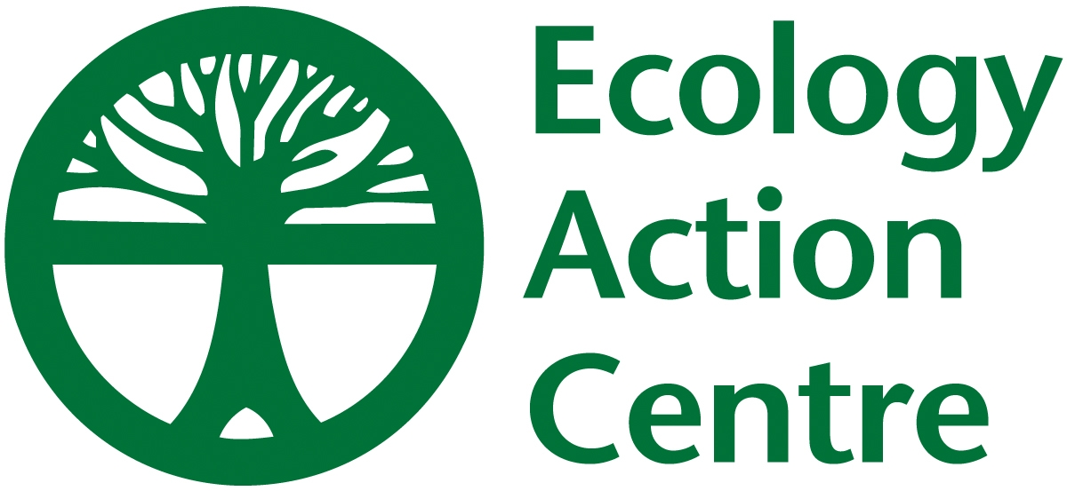
PRESS RELEASE

Turkey Takes Sweeping Action to Protect Endangered Sharks & Rays
Conservation Groups Applaud Big Step Toward Safeguarding Mediterranean Species

London, UK. April 20, 2018. A year after denouncing Turkey for the landing of 30 Endangered Giant Devil Rays, the Shark League is applauding the country for announcing protections for this and 13 other species of rays and sharks. The fish are being added to the government’s list of prohibited species, which until now included only five kinds of sharks.
“Turkey’s new rules will help safeguard some of the most threatened sharks and rays in our oceans, including Critically Endangered angel sharks and Shortfin Makos,” said Ali Hood, Director of Conservation for the Shark Trust. “We congratulate the Turkish government officials and conservation groups involved in this decision. It represents a significant step toward Mediterranean shark and ray conservation and a solid example for other countries in the region.”
In 2012 the General Fisheries Commission for the Mediterranean (GFCM), which includes Turkey, adopted a measure to end fishing and retention of 24 imperiled shark and ray species listed under a special protocol of the Barcelona Convention. Implementation at national levels, however, has been slow.
“We are particularly excited to welcome Turkey’s first protections for skates and rays, as these exceptionally vulnerable species are too often overlooked,” said Sonja Fordham, President of Shark Advocates International, a project of The Ocean Foundation. “We are relieved that our calls to prevent another significant take of Giant Devil Rays have been heeded, and also pleased to see new protections for six other ray and skate species, especially the Mediterranean’s two Endangered guitarfishes.”

SHARK & RAY SPECIES GAINING NEW PROTECTIONS IN TURKEY
Species included under GFCM measure |  |  | Species not included under GFCM measure
Common name | Scientific Name | IUCN Red List Status  (Mediterranean) | Common name | Scientific name | IUCN Red List Status  (Mediterranean)
Shortfin Mako | Isurus oxyrinchus | Critically Endangered | Bull Ray | Pteromylaeus bovinus | Critically Endangered
Angular Rough Shark | Oxynotus centrina | Critically Endangered | Common Thresher | Alopias vulpinus | Endangered
Smoothback Angelshark | Squatina oculata | Critically Endangered | Common Eagle Ray | Myliobatis aquila | Vulnerable
Sawback Angelshark | Squatina aculeata | Critically Endangered | Thornback Skate | Raja clavata | Near Threatened
Angelshark | Squatina squatina | Critically Endangered | Longnose Spurdog | Squalus blainville | Data Deficient
Giant Devil Ray | Mobula mobular | Endangered | Spinetail Devil Ray | Mobula japanica | -
Blackchin Guitarfish | Rhinobatos cemiculus | Endangered | For more information, see IUCN Mediterranean Shark Status Report
Common Guitarfish | Rhinobatos rhinobatos | Endangered
(Before this action, Turkey had prohibited take of Basking Sharks, Spurdog, Porbeagle, Tope, and Sandbar Sharks.)

The Shark League will use a GFCM Working Group meeting next week in Beirut as an opportunity to press for continued progress towards full implementation of the 2012 GFCM shark and ray measure. Specifically, the coalition is urging other Mediterranean countries to follow Turkey’s lead in protecting endangered sharks nationally, while encouraging Turkey to protect the remaining species listed in the GFCM measure, including Smooth Hammerheads, Spiny Butterfly Rays, and White Sharks.

Media contact : Patricia Roy, tel: +34 696 905 907, email: patricia@communicationsinc.co.uk

Shark Trust, Shark Advocates International, Project AWARE, and Ecology Action Centre form the Shark League, a coalition focused on responsible regional conservation of sharks and rays in the Atlantic and Mediterranean.

