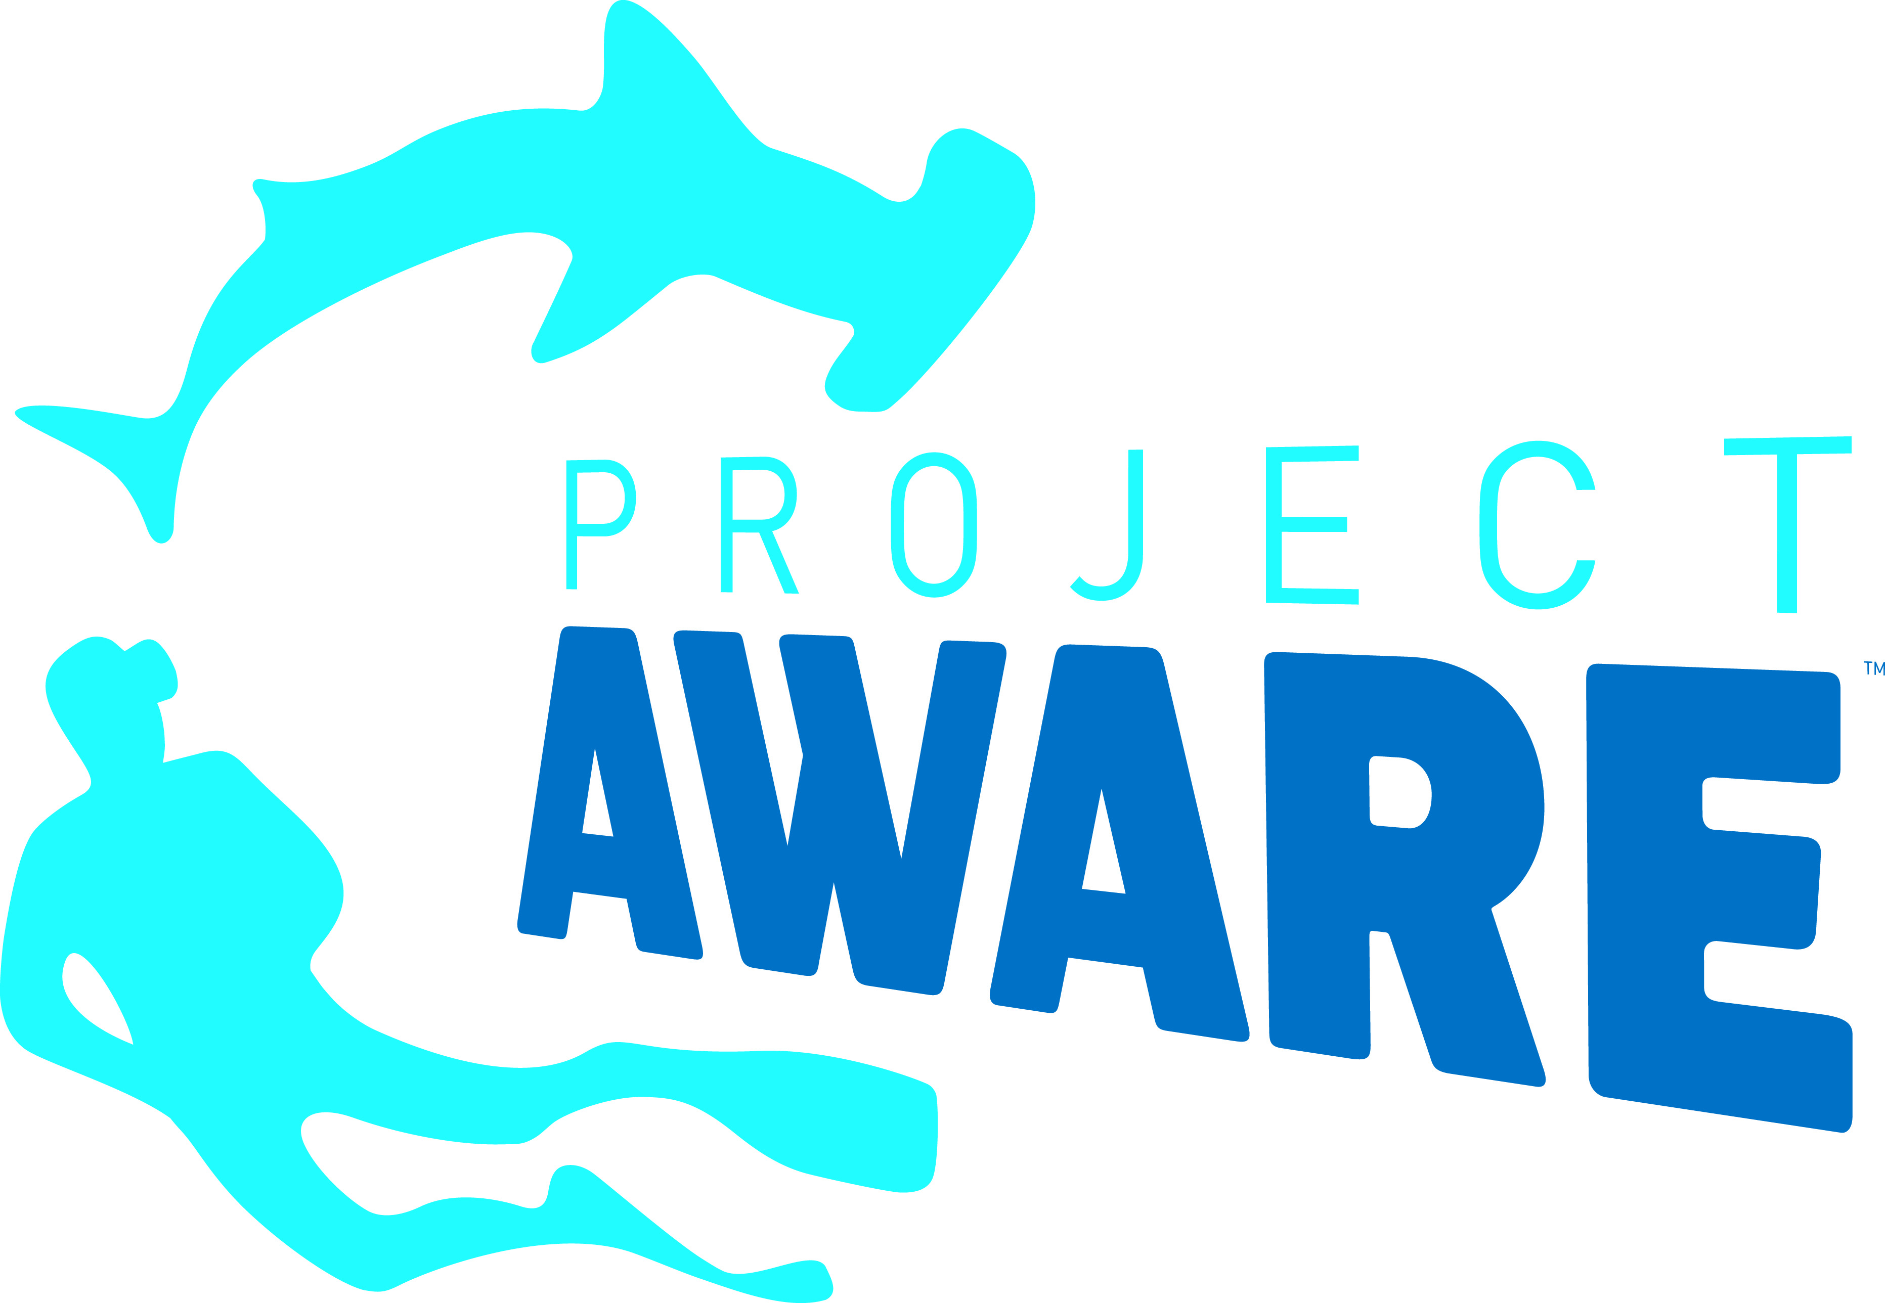
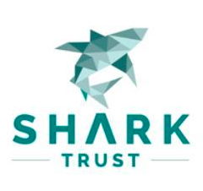
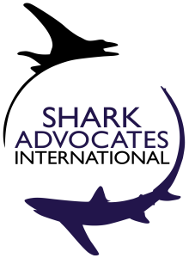

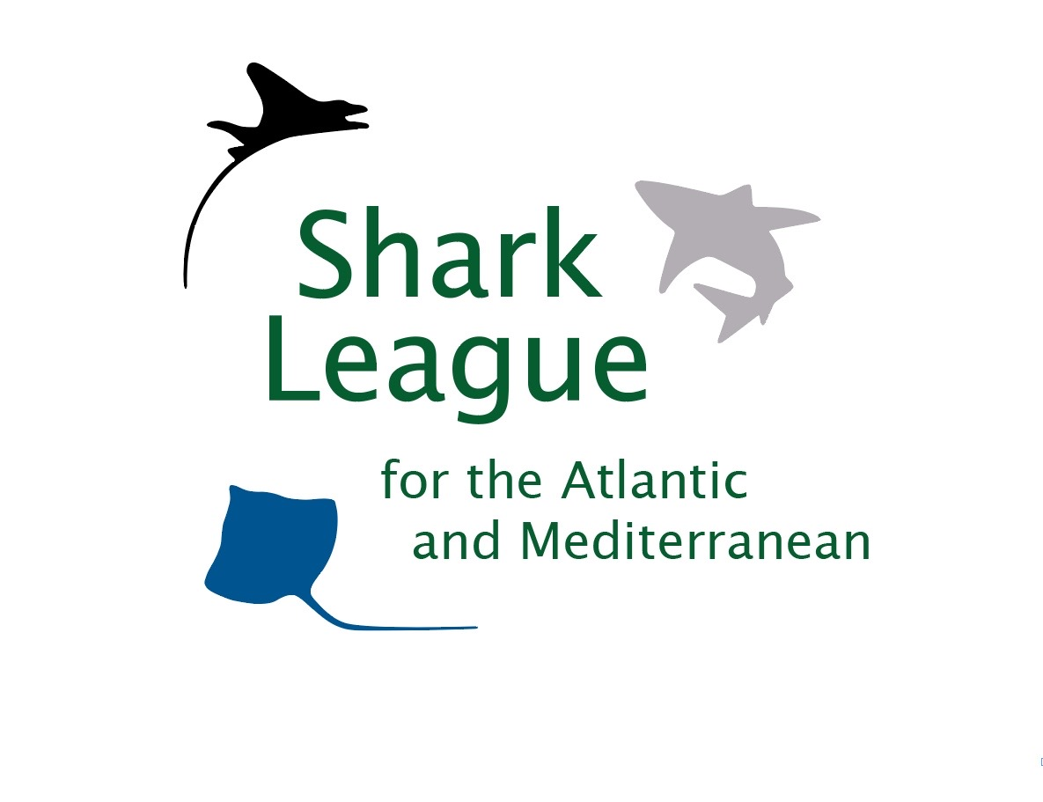
PRESS
RELEASE

Canada Protects Endangered Mako Sharks with Groundbreaking Atlantic Ban

Halifax, Nova Scotia, April 22nd, 2020. Conservationists are welcoming a science-based decision by the Canadian government to end all retention of endangered shortfin mako sharks in Atlantic fisheries. With this action, Canada becomes the first North Atlantic country to heed a longstanding recommendation from International Commission for the Conservation of Atlantic Tunas (ICCAT) scientists to prohibit retention of shortfin makos from the region. Such action is urgently needed across the North Atlantic to end overfishing and rebuild the seriously depleted population. Canada recently ranked fifth among ICCAT Parties for North Atlantic shortfin mako landings.

“We applaud the Canadian government for stepping up to protect one of the Atlantic’s most threatened sharks, the shortfin mako,” said Shannon Arnold, Marine Program Coordinator for Ecology Action Centre. “Today’s action represents a milestone in Canada’s remarkable emergence as a leader in global shark conservation, and one of the most significant steps to date in an urgent effort to save this exceptionally imperiled mako population.”

Shortfin makos are particularly valuable sharks, sought for meat, fins, and sport. Slow growth makes them exceptionally susceptible to overfishing. Makos are fished by many nations around the globe yet not subject to international fishing quotas. ICCAT scientists have reported serious North Atlantic shortfin mako declines and have recommended a ban on retention, in addition to other measures, since 2017. They estimate that rebuilding will likely take ~50 years, even if mako fishing stops.

At the November 2019 ICCAT meeting, Canada joined Senegal and 14 other countries in urging international adoption of scientific advice for makos. Competing, lenient proposals from the US and EU prevented consensus, thereby postponing decisions on international remedies to 2020. The COVID-19 pandemic has since created uncertainty around this year’s ICCAT agenda, making unilateral actions by mako fishing Parties all the more vital as stop-gap options to stem population decline.

“Although similar action is needed by other countries to save the highly migratory mako shark, Canada’s new ban is a pivotal development for this valuable, vulnerable species,” said Sonja Fordham, President of Shark Advocates International. “We urge other North Atlantic fishing nations to follow Canada’s lead to protect this shared population, as scientists advise.”
Global concern over mako shark depletion was recognized through a 2019 listing on Appendix II of the Convention on International Trade in Endangered Species (CITES), as proposed by 27 countries and the EU. CITES Parties -- including ICCAT Parties -- are required to ensure that mako exports are sourced from legal, sustainable fisheries.
“While we wait for ICCAT action, overfishing of the endangered North Atlantic mako population is continuing, with most of the catch not subject to any fishing limits,” said Ali Hood, Director of Conservation for the Shark Trust. “Following scientific advice and Canada’s example now will lessen ecological and economic disruption in the long term.”
Media contacts: Shannon Arnold: +1 902 329-4668, sarnold@ecologyaction.ca; Patricia Roy: +34 696 905 907, patricia@communicationsinc.co.uk

Notes to Editors: Shark Advocates International is a project of The Ocean Foundation dedicated to securing science-based policies for sharks and rays. The Shark Trust is a UK charity working to safeguard the future of sharks through positive change. Ecology Action Centre promotes sustainable, ocean-based livelihoods, and marine conservation in Canada and internationally. Project AWARE is a global movement for ocean protection powered by a community of adventurers. These groups, with support from the Shark Conservation Fund, formed the Shark League to advance responsible regional shark and ray conservation policies.

The Shark League made its latest appeal for a Canadian mako ban in a letter to the Fisheries Minister on April 2nd.

The Canadian government made the change through the annual Atlantic fishery license conditions.
The shortfin mako shark is classified as Endangered on the IUCN Red List.
ICCAT is responsible for the conservation of tunas and tuna-like species in the Atlantic Ocean and adjacent seas. ICCAT has 53 Contracting Parties. In 2019, ICCAT scientists updated the status of Atlantic shortfin makos and estimated that cutting annual catches (including dead discards) to ~300t would give this slow-growing population a 60% chance of rebuilding in 50 years.
Retention bans can be effective in significantly reducing shortfin mako mortality as post-release survival can be as high as 75%.
The 2019 ICCAT proposal from Canada and Senegal for science-based mako limits was supported by Gambia, Gabon, Panama, Liberia, Guatemala, Angola, El Salvador, Egypt Norway, Guinea Bissau, Uruguay, Japan, China, and Taiwan.

Countries reporting 2018 catches of North Atlantic makos (Isurus oxyrinchus) include (in order of magnitude): EU (Spain and Portugal), Morocco, US, Senegal, Canada, Japan, Belize, Korea, Mexico, and Trinidad & Tobago. EU fishing vessels are responsible for 60% of North Atlantic shortfin mako catches reporting for 2018.

