
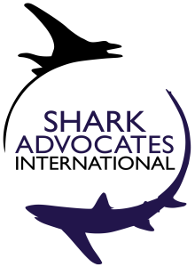


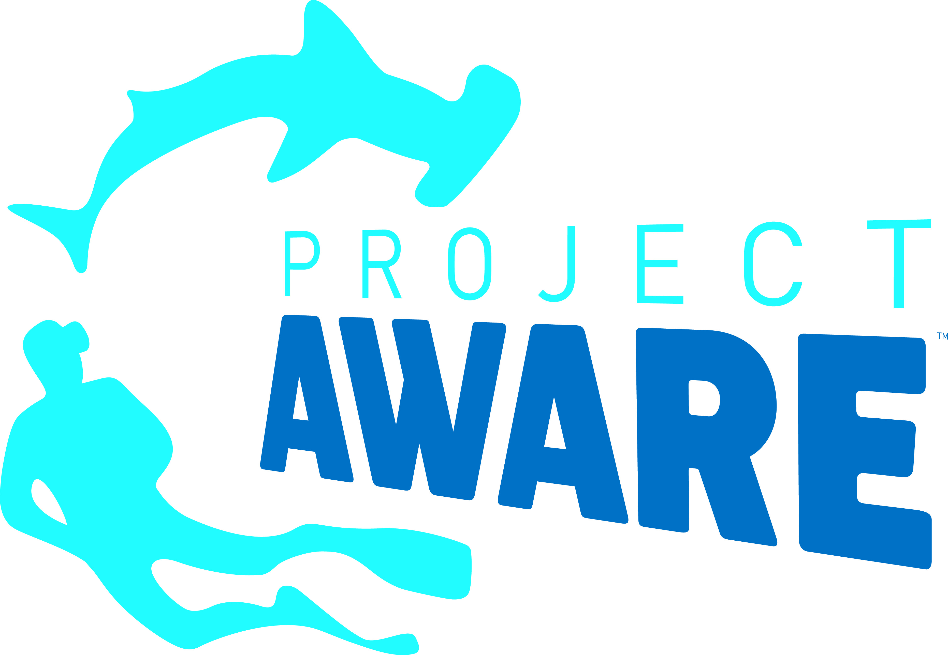
Media Advisory

Make or Break Time for Endangered Atlantic Mako Sharks
What: Proposals for groundbreaking international fishing restrictions to reverse shortfin mako shark population declines and prevent shark finning in the Atlantic.
Who: Representatives of nations fishing the Atlantic high seas gathering for the annual meeting of the International Commission for the Conservation of Atlantic Tunas (ICCAT), a Regional Fishery Management Organization (RFMO) with 53 Contracting Parties (including the European Union).
When & where: November 18-25, 2019, Congress Palace, Palma de Mallorca, Spain.

Why it’s important: Sharks are among the most vulnerable animals taken in high seas fisheries. North Atlantic makos have been seriously overfished and are headed for collapse. ICCAT has yet to align its finning ban with best practice. Proposals to address these issues, if adopted, would set precedents that could improve the outlook for sharks on a global scale.
Mako sharks: Prized for meat, fins, and sport, shortfin makos are among the Atlantic’s most imperiled sharks. They are fished across entire ocean basins by many nations, and yet there are no international mako catch limits. Earlier this year, makos were classified by the International Union for Conservation of Nature (IUCN) as Endangered and listed under the Convention on International Trade in Endangered Species (CITES). A new report from ICCAT scientists demonstrates that shortfin mako catches from the North Atlantic must be minimized in order to stop overfishing and allow the population to recover over several decades. They have advised a ban on retention, which has since been proposed by Senegal. The host country – Spain – is responsible for more mako landings than any other nation. Other countries reporting significant catches of North Atlantic makos include (in order of magnitude): Morocco, Portugal, the United States, Senegal, and Canada.
Finning bans: ICCAT’s ban on the wasteful practice of finning (slicing off a shark's fins and discarding the body at sea) is difficult to enforce because a complicated fin-to-body weight ratio is used to monitor compliance. Requiring that sharks be landed with fins attached is the most reliable way to prevent finning and can also yield species-specific shark catch data, which is critical for population assessment. The U.S. has led efforts to strengthen the ICCAT finning ban through this increasingly popular “fins attached” method, but opposition from Japan has prevented consensus for nearly a decade. This is the tenth year that such a requirement is being proposed for ICCAT. So far, Albania, Belize, Brazil, Cabo Verde, Canada, Curaçao, the EU, France (on behalf of St Pierre and Miquelon), Gabon, Ghana, Guatemala, Honduras, Nicaragua, Norway, Panama, Sao Tomé and Principe, Senegal, Sierra Leone, UK Overseas Territories, and South Africa are co-sponsoring a fins-attached proposal initiated by the U.S.

Media contact:
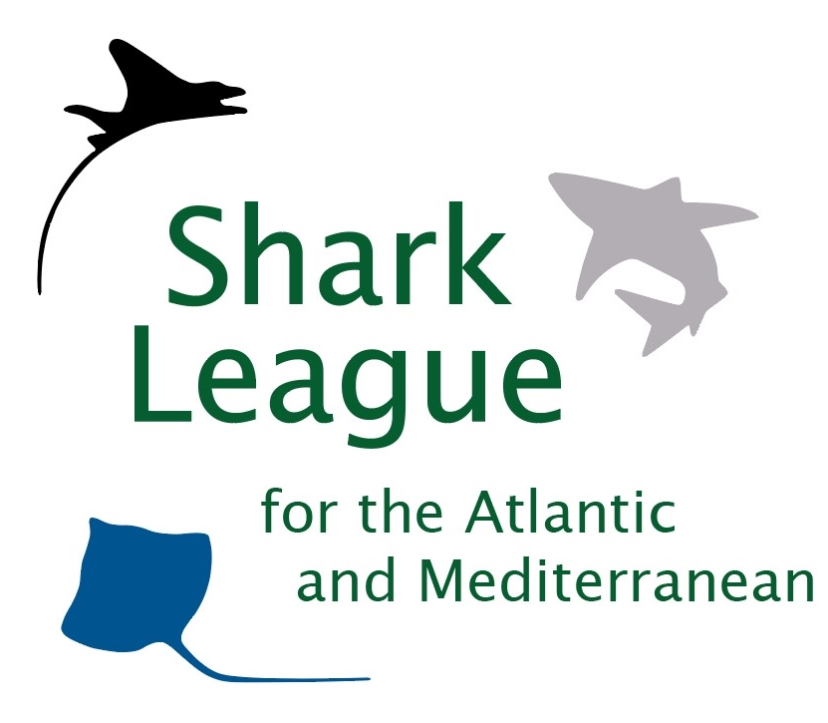
Notes to editors:
The proposals for ICCAT shark measures can be found at: www.iccat.int/com2019/index.htm#en
Shark Advocates International, Ecology Action Centre, Shark Trust, and Project AWARE, are collaborating to safeguard Atlantic and Mediterranean sharks through Regional Fishery Management Organizations: www.sharkleague.org

