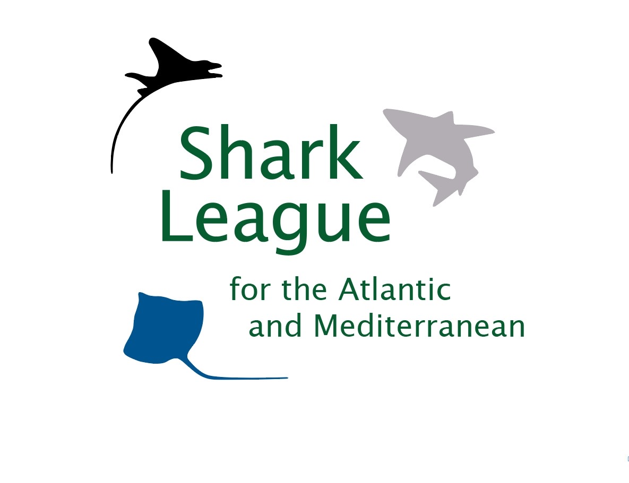
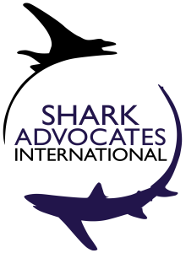
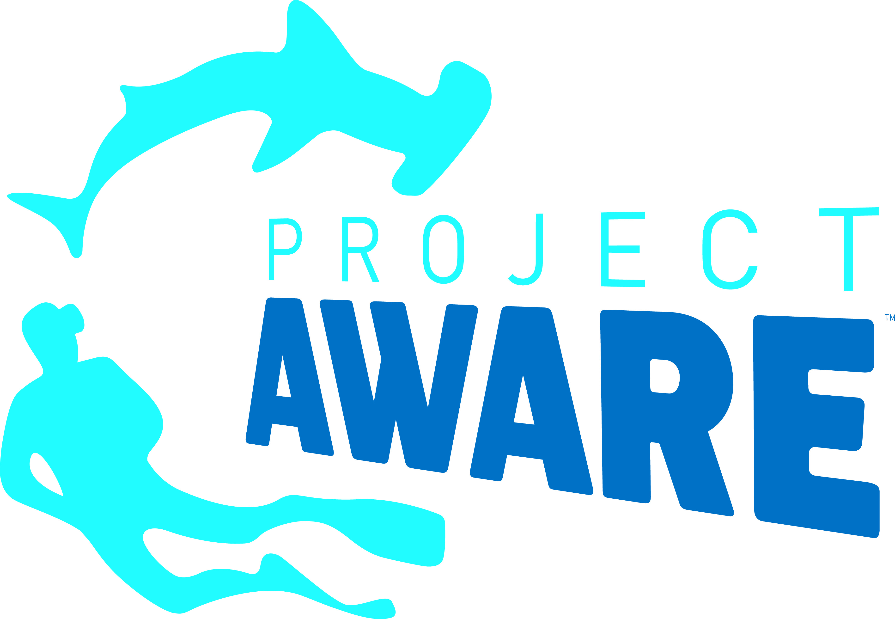


PRESS
RELEASE

Shark Fishing Decisions at Atlantic Tuna Meeting Fall Short
Slow course set for protecting makos, stronger finning ban narrowly defeated at ICCAT

Marrakech, Morocco. November 21, 2017. Fishing nations gathered for the annual meeting of the International Commission for the Conservation of Atlantic Tunas (ICCAT) have failed to adopt recommended limits to protect shortfin mako sharks from overfishing or strengthen the regional ban on shark finning. The only new shark agreement resulting from the eight day meeting takes a phased in approach to narrow the conditions under which shortfin makos can be landed, but includes numerous exceptions and applies only to the North Atlantic. ICCAT’s scientists had recommended mako catch cuts in the South Atlantic, and a full ban on retention in the North Atlantic to allow the depleted population to rebuild over 20 years.

“We are deeply disappointed that ICCAT has fallen so short of the clearest scientific advice to date for shortfin mako sharks, and are thereby leaving this exceptionally vulnerable species at risk for population collapse,” said Sonja Fordham, President of Shark Advocates International, a project of The Ocean Foundation. “This measure is only a first step to addressing a true crisis for North Atlantic makos, and must be viewed as a wake up call and springboard for additional action, including immediate catch reductions.”
The EU, US, and Japan proposed cutting North Atlantic mako catch from current levels (~3400t) to 500t, the level that would stop overfishing, along with other measures. Morocco, the host country whose mako landings are on the rise, countered with 1500t. In the end, the Parties could not agree on a catch limit and instead mandated that North Atlantic makos brought to boat alive must be carefully released, unless the country has imposed a minimum size limit (at the length of maturity) or a discard ban (that prevents profit). Dead makos can be still be landed (and sold) by boats under 12 meters, as well as by larger vessels under certain conditions for monitoring catch and reporting data. Whether new restrictions end up cutting catch sufficiently to stop overfishing will be evaluated in 2018. ICCAT can take additional action then, and has ordered scientific analyses in 2019 on which to develop a more comprehensive rebuilding plan.

An EU proposal to limit South Atlantic shortfin mako catches to 2000t, as advised by scientists, failed after Brazil announced their need to have the tonnage allocated to individual Parties, effectively running out the clock.

“We now turn our focus to the top mako fishing countries, particularly those that still have no limits on mako catch: Spain, Portugal, Morocco, and Brazil,” said Ali Hood, Director of Conservation for the Shark Trust. “We urge these countries and the EU to begin work immediately on measures to halt mako overfishing and begin rebuilding the beleaguered North Atlantic population, and to curb South Atlantic catches to avoid a similar crisis there.”

Twenty-two Parties -- including, for the first time, Canada -- co-sponsored a proposal to strengthen the ICCAT ban on finning (slicing off a shark’s fins and discarding the body at sea) by replacing a problematic fin-to-carcass ratio with a more enforceable requirement that sharks be landed with their fins attached. Cote d’Ivoire, Iceland, Nigeria, Sierra Leone, and the Republic of Guinea joined the chorus of support from the floor. Just two countries -- Japan and China -- blocked the measure, as they have for several years.

“We are dismayed that Japan and China have yet again stood in the way of an enforceable ICCAT shark finning ban proposed by Parties from all sides of the Atlantic,” said Ania Budziak, Associate Director for Project AWARE. “We are pleased, however -- after much work with colleagues and scuba divers -- to welcome Canada as a new co-sponsor of this key initiative to promote best practices for responsible shark fisheries management.”
Media contacts: Sophie Hulme, email: sophie@communicationsinc.co.uk, tel: +447973712869

Notes to Editors: Shark Advocates International is a project of The Ocean Foundation dedicated to securing science-based policies for sharks and rays. The Shark Trust is a UK charity working to safeguard the future of sharks through positive change. Focused on sharks in peril and marine debris, Project AWARE is a growing movement of scuba divers protecting the ocean planet – one dive at a time. Ecology Action Centre promotes sustainable, ocean-based livelihoods, and marine conservation in Atlantic Canada. These groups have formed the Shark League (www.sharkleague.org) and also collaborate toward shark conservation goals with WWF and Defenders of Wildlife.
Mako sharks (Isurus oxyrinchus) are valued for meat, fins, and sport. This highly migratory species is fished by many countries across the Atlantic.

Countries landing North Atlantic makos include (in order of magnitude for 2011-2016 reported catches): Spain, Morocco, Portugal, US, Japan, and Canada.

Countries landing South Atlantic makos include (in order of magnitude for 2011-2016 reported catches): Spain, Namibia, South Africa, Portugal, Taiwan, Japan, and Brazil.

In recent years (2011-2016), EU fishing vessels have been responsible for nearly 65% of North Atlantic shortfin mako landings, and 47% of those taken from the South Atlantic. Morocco’s reported landings of North Atlantic shortfin makos more than doubled from 2011 to 2016.

Shortfin makos ranked first among 20 pelagic shark stocks for vulnerability to ICCAT fisheries based on Euclidean distance and third overall in an Ecological Risk Assessment for sharks conducted by ICCAT scientists in 2012.

ICCAT is responsible for the conservation of tunas and tuna-like species in the Atlantic Ocean and adjacent seas. ICCAT has 52 Contracting Parties, including the European Union. ICCAT adopted protections for bigeye thresher sharks in 2009, oceanic whitetip sharks and hammerheads* in 2010, silky sharks* in 2011, and porbeagles* in 2015 (*= with exceptions).
High demand for fins drives many shark fisheries and provides incentive for finning. The current ICCAT finning ban is difficult to enforce because of a complicated fin-to-body weight ratio used to monitor compliance. Requiring that sharks be landed with fins attached (as is required in the EU, US, and elsewhere) is the most reliable way to prevent finning, and can also yield better catch data, which is critical for population assessment.

Map of the ICCAT Parties co-sponsoring and/or supporting fins-attached proposals (2015-2017):
