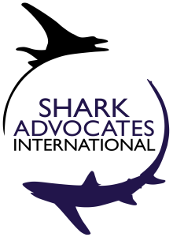
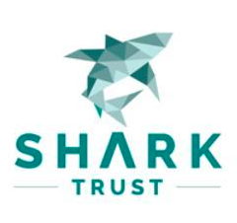

News Release Media Contacts:
Liz Morley (SAI): +1 843 693 5044,
Heather Grant (EAC): +1 902 449-7640

Northwest Atlantic Fishing Countries Take Action for Sharks:
Cuba & Norway Help US & EU Win Stronger Finning Ban Despite Japan’s Objection
Greenland Sharks Get Spotlight While Skates Remain At-Risk

Varadero, Cuba. September 23, 2016. In a rare vote, the Northwest Atlantic Fisheries Organization (NAFO) has adopted a proposal for a stronger shark finning ban by an overwhelming margin, despite objections from Japan. The European Union and the United States have proposed for several years that NAFO strengthen its ban on shark “finning” (slicing off a shark’s fins and discarding the body at sea) by prohibiting the removal of shark fins at sea. This year, the proposal was for the first time co-sponsored by Norway and the host country of Cuba, and gained new, outspoken support from Canada and Iceland. A similar ban was adopted by the North East Atlantic Fisheries Commission in 2014, but other regional fisheries bodies have yet to accept such change.

“We are elated that North Atlantic fishing countries have taken a strong stand against shark finning and are leading the way toward adoption of best practice rules to prevent it globally,” said Sonja Fordham of Shark Advocates International. “We are deeply grateful to Cuba, our host country, for introducing the finning ban measure at this year’s meeting, and bringing it over the finish line at last.”

NAFO banned finning in 2005, but allows fins to be removed at sea, as long as the fin-to-carcass weight ratio does not exceed 5%. Using ratios has proved difficult for enforcing finning bans, while “fins-attached” landing rules are widely recognized as best practice. The US and EU are expected to re-introduce a fins-attached proposal at the International Commission for the Conservation of Atlantic Tunas (ICCAT) meeting in November.
This year’s NAFO meeting marks a dramatic policy change for Canada and Korea, who helped defeat the “fins-attached” measure in 2015. Overall, nine NAFO Parties voted “yes” on the proposal, Japan voted “no,” and Russia abstained.

“We are thrilled that Canada has -- at long last – joined the chorus of countries supporting this cornerstone of responsible shark fisheries management,” said Katie Schleit of Ecology Action Centre. “We are grateful for their enthusiastic support and hopeful that this new, national policy means that Canada will now join 30 other countries cosponsoring stronger finning bans and other safeguards for sharks at ICCAT.”
NAFO Parties also requested of their Scientific Council management advice for the Greenland shark, the subject of widespread media coverage and conservation concern last month after scientists reported the species can live 400 years. Parties also took steps that should result in better information on the other species of sharks and skates taken as “bycatch” in fisheries targeting other fish species: a mandate for collecting data on a haul-by-haul basis, and the development of shark and skate species identification guides for observers.
For the annual skate catch limit, however, NAFO Parties kept the status quo of 7,000t. NAFO scientists recommend catches not exceed 4,700t and report little rebuilding for the target species (thorny skate aka starry skate) after more than a decade of NAFO management. Thorny skate is listed by IUCN as threatened.
"We are grateful to the EU and US for taking a strong stand on more enforceable finning bans, thereby leading the charge to minimize waste of sharks," said Ali Hood of Shark Trust. "At the same time, we are deeply disappointed that no NAFO Parties stepped up as champions for closely related skates. As a result, quotas once again exceed scientific advice, leaving these vulnerable species at risk for further depletion."
NAFO Contracting Parties include Canada, Cuba, Denmark (in respect to the Faroe Islands & Greenland), the European Union, France (in respect to Saint Pierre et Miquelon), Iceland, Japan, Republic of Korea, Norway, Russian Federation, Ukraine, and the US. NAFO Parties develop international management measures for Northwest Atlantic fish (except salmon, tunas/marlins, and sedentary species).

