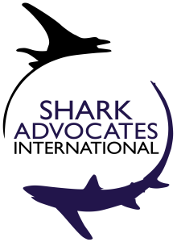
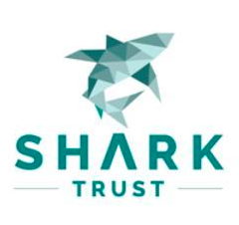

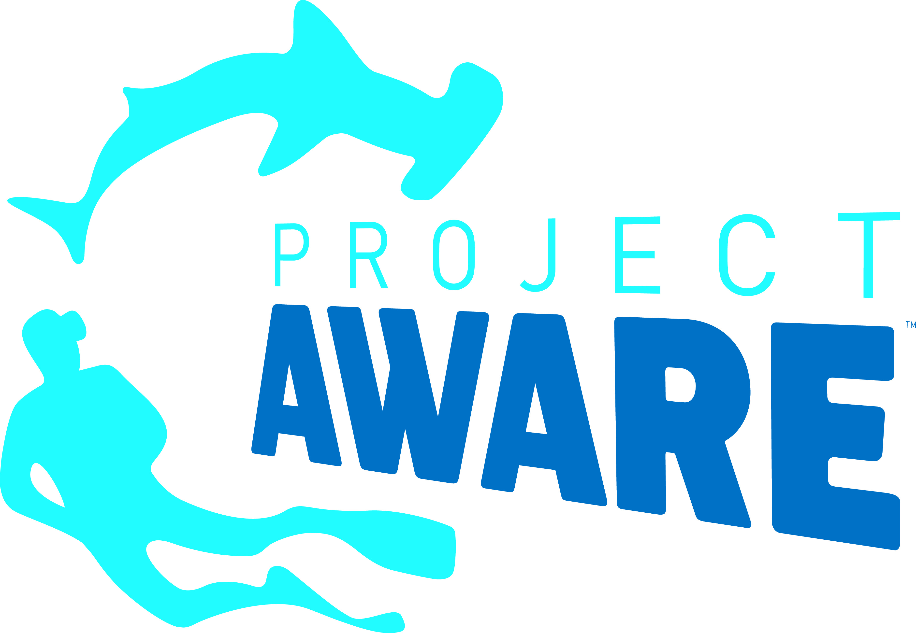
PRESS RELEASE

Baby Step for Blue Sharks, New Voices Against Finning at Atlantic Tuna Meeting
ICCAT fishery managers aim to cap North Atlantic blue shark catch as momentum to ban at-sea fin removal grows

Vilamoura, Portugal. Monday, November 21, 2016. Fishing nations gathered for the annual meeting of the International Commission for the Conservation of Atlantic Tunas (ICCAT) have taken a small yet unprecedented step toward establishing limits on blue shark catches from the North Atlantic, but failed to act on scientific advice to do the same for the South Atlantic. Countries also mounted an extraordinary effort to strengthen the international ban on shark “finning” that was eventually thwarted by Japan and China.

"Sharks are among the oceans’ most inherently vulnerable animals, and unenforceable half-measures are not enough to conserve them,” said Sonja Fordham, President of Shark Advocates International. “While we welcome Atlantic nations’ growing interest in preventing shark finning, and their recognition that blue shark fishing cannot continue without limit, we are deeply disappointed that much scientific advice has gone unheeded, and that the region’s finning ban will remain weak despite the will of more than 30 countries."
Blue sharks are fished by many countries, most of which do not limit catch. They dominate the shark landings from ICCAT fisheries and the global shark fin trade. Atlantic blue shark landings tripled in the last decade. To prevent overfishing, ICCAT scientists have recommended capping blue shark catches, particularly in the South Atlantic. An EU proposal to limit blue shark landings from both the North and South Atlantic was watered down by Japan and others; Brazil blocked conservation action for the South Atlantic. The final agreement triggers ICCAT consideration, but not necessarily catch limits, if North Atlantic blue shark landings exceed recent levels (~39,000 metric tons).
More than 85% of reported North Atlantic blue shark landings have been taken by EU vessels in recent years.
"It is critical to recognize that ICCAT’s new blue shark measure applies only to the North Atlantic and depends on follow-up actions by individual nations in the short-term and by ICCAT in the long-term,” said Ali Hood, Director of Conservation for the Shark Trust. "Given that Spanish vessels take the lion’s share of the North Atlantic blue shark catch, it now falls squarely with the EU to immediately set blue shark catch limits, in line with commitments made today. Only with such EU action can this half-measure result in meaningful blue shark conservation.”

Eighty percent of ICCAT Parties attending the meeting supported a US-led, multi-national effort to strengthen the ICCAT finning ban by replacing a problematic fin-to-carcass ratio with a more enforceable prohibition on removing fins at sea. Norway, Liberia, St. Vincent and the Grenadines, Nicaragua, Sierra Leone, Curaçao, and Libya co-sponsored this year’s “fins-attached” proposal, along with 23 other ICCAT Parties that proposed the measure last year. For the first time, Canada spoke in favor of the ban and Korea did not voice opposition. The EU, South Africa, Venezuela, Iceland, Russia, Senegal, and several other West African nations joined the chorus of support offered on the floor. In the end, however, Japan and China – with a little help from Morocco -- blocked the proposal.

“We are dismayed that just a few countries have yet again stood in the way of an enforceable ICCAT finning ban proposed by 30 Parties from all sides of the Atlantic,”said Ania Budziak, Associate Director for Project AWARE. “We are heartened, however, by the compelling demonstration of support for fins-attached rules from developing and developed countries alike, and encourage continued momentum towards this best practice.”
The conservation groups will continue to press ICCAT and its members to limit shark fishing and prevent finning.
Media contacts: Sophie Hulme, email: sophie@communicationsinc.co.uk, tel: +447973712869

Notes to Editors: Shark Advocates International is a project of The Ocean Foundation dedicated to securing science-based policies for sharks and rays. The Shark Trust is a UK charity working to safeguard the future of sharks through positive change. Focused on sharks in peril and marine debris, Project AWARE is a growing movement of scuba divers protecting the ocean planet – one dive at a time. Ecology Action Centre promotes sustainable, ocean-based livelihoods, and marine conservation in Atlantic Canada. These groups collaborate toward shark conservation goals with Defenders of Wildlife, who delivered testimony for the coalition at the ICCAT meeting. Joint NGO position statement on these issues: http://www.iccat.int/com2016/TRI/PA4_815.pdf
Shark fins are used in a celebratory soup in Asia. High demand for fins drives many shark fisheries and provides incentive for finning (the wasteful practice of slicing off a shark's fins and discarding the body at sea). Blue sharks are the dominant species in the global shark fin trade and are also used for their meat.

The current ICCAT finning ban is difficult to enforce because of a complicated fin-to-body weight ratio used to monitor compliance. Requiring that sharks be landed with fins attached (as is required in the EU, US, and elsewhere) is the most reliable way to prevent finning, and can also yield better catch data, which is critical for population assessment.

More than 60,000 metric tons of blue sharks were taken from the Atlantic in 2015. ICCAT scientists have recommended precautionary measures to prevent overfishing of sharks in cases where the population status is uncertain; more specifically, they have advised action to ensure that South Atlantic blue shark catches do not increase. ICCAT scientists are not due to revisit blue shark population status and related advice on catches until 2021.

Countries reporting significant catches of Atlantic blue shark include (in order of magnitude): Spain, Japan, Portugal, Chinese Taipei, Namibia, Brazil, Ghana, South Africa, Uruguay, and the Republic of Korea.

In recent years, EU fishing vessels have been responsible for more than 85% of blue shark landings reported from the North Atlantic and more than 75% of total Atlantic blue shark landings (2006-2015).

The new ICCAT blue shark measure states, among other things, “If the average total catch of the North Atlantic blue shark in any consecutive two years from 2017 onward exceeds the average level observed during the period 2011-2015 (i.e. 39,102 t), the Commission shall review the implementation and effectiveness of these measures.
Full text: http://www.iccat.int/com2016/DocENG/PA4_816C_ENG.pdf

ICCAT is responsible for the conservation of tunas and tuna-like species in the Atlantic Ocean and adjacent seas. ICCAT has 51 Contracting Parties, including the European Union. ICCAT adopted protections for bigeye thresher sharks in 2009, oceanic whitetip sharks and hammerheads* in 2010, silky sharks* in 2011, and porbeagles* in 2015 (*= with exceptions).
Proposal for stronger finning ban: http://www.iccat.int/com2016/DocENG/PA4_803B_ENG.pdf
Map of the 30 ICCAT Parties cosponsoring the 2016 fins-attached proposal:
