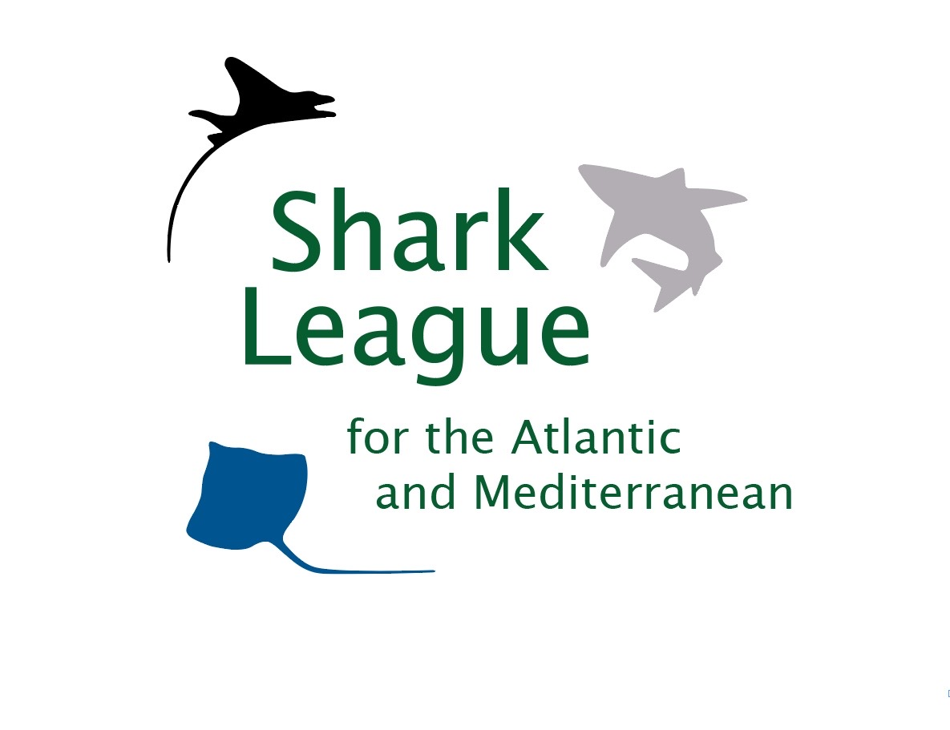
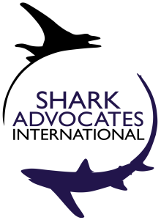
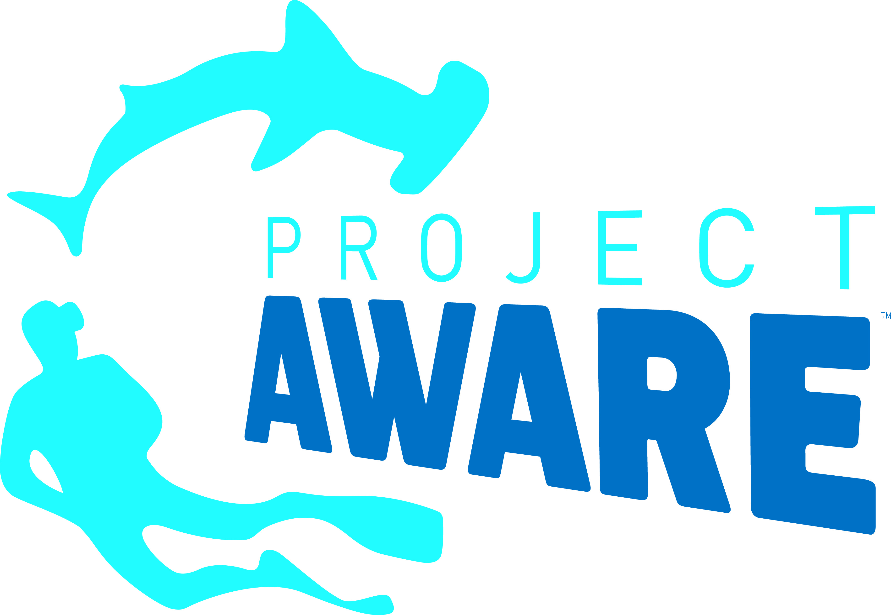
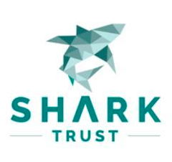

PRESS
RELEASE

Scientists Issue Grim Status Update on Atlantic Mako Sharks, Recommend Full Ban
Conservationists put the spotlight on the EU for inaction and hypocrisy

London. 24 June, 2019. A new report shows that the overfished North Atlantic Shortfin Mako Shark population is continuing to decline and needs not only immediate protection but several decades to recover. Based on new projections for mako populations, scientists associated with the International Commission for the Conservation of Atlantic Tunas (ICCAT) amplified previous warnings and recommended a North Atlantic ban on retention. Because of depletion to date and an exceptionally low reproductive rate, this population is predicted to continue to decline for another fifteen years before rebuilding can begin.

“Shortfin makos are among the most vulnerable and valuable sharks taken on the high seas, and yet fishery managers have continually put populations at outrageously high risk, allowing serious overfishing year after year,” said Sonja Fordham, President of Shark Advocates International, a project of The Ocean Foundation. “The dire state of North Atlantic makos represents a conservation emergency that calls for immediate retention bans.”

The Shortfin Mako – the world’s fastest shark — is sought for meat, fins, and sport, but most fishing nations have yet to impose basic limits on catch. Scientists have pushed the earliest possibility of North Atlantic population recovery to 2045, five years later than predicted just two years ago. This scenario has a 53% chance if all mortality is ended. If annual Shortfin Mako catches from across the North Atlantic (including those discarded dead) are cut from recent levels (~3000t) to below 300t in 2020, recovery will likely take 50 years (60% probability).

Fleets from the European Union (EU), primarily Spain, take more makos than any other ICCAT Party and are not subject to any limits on catch. Spain will host the annual ICCAT meeting where the scientists’ advice for makos will be considered. In the meantime, the EU is co-sponsoring a proposal (for decision in August) to list mako sharks on Appendix II of the Convention on International Trade in Endangered Species (CITES), which would obligate Parties to regulate exports based on determinations that products are legally and sustainably sourced.

“The EU is rightfully asking all fishing countries to ensure the sustainability of their mako catches and yet has failed in the face of repeated scientific advice to set basic fishing quotas for the species, all while taking by far the greatest share,” said Ali Hood, Shark Trust, Director of Conservation. “It is beyond time for the EU to end this hypocrisy and step up with the complete Shortfin Mako ban needed to prevent an even greater disaster.”

Scientists also flagged significant risk that South Atlantic Shortfin Makos will follow a similar path. They recommend that ICCAT establish a catch limit at or below recent minimum levels (~2,000 t).

Media contact: Patricia Roy, email: patricia@communicationsinc.co.uk, telephone: +34 696 905 907.

Notes to Editors: Shark Advocates International is a project of The Ocean Foundation dedicated to securing science-based policies for sharks and rays. The Shark Trust is a UK charity working to safeguard the future of sharks through positive change. Project AWARE® is a global movement focused on connecting ocean adventures with the purpose of marine conservation for a return to a clean and healthy ocean. Ecology Action Centre promotes sustainable, ocean-based livelihoods, and marine conservation in Canada and internationally. These groups, with support from the Shark Conservation Fund, formed the Shark League of the Atlantic and Mediterranean to advance responsible regional shark and ray conservation policies (www.sharkleague.org).

The recently updated ICCAT assessment for Shortfin Mako Sharks is posted here: https://www.iccat.int/Documents/Meetings/Docs/2019/REPORTS/2019_SMA_SA_ENG.pdf

Mako sharks (Isurus oxyrinchus) are valued for meat, fins, and sport. This highly migratory species is fished by many countries. Female shortfin makos mature at 18 and usually have 10-18 pups every three years after a 15-18-month gestation. A 2012 Ecological Risk Assessment found makos exceptionally vulnerable to Atlantic pelagic longline fisheries. Earlier this year, the IUCN Shark Specialist Group classified the Shortfin Mako as Globally Endangered based on the IUCN Red List criteria.

Studies show makos released alive from longlines have a 75% chance of surviving; a ban on retention could therefore be effective. Scientists note that additional measures, including fishing area closures, gear restrictions, and best practices for handling could help the population recover.

ICCAT is responsible for the conservation of tunas and tuna-like species in the Atlantic Ocean and adjacent seas. ICCAT has 53 Contracting Parties, including the European Union.

Countries reporting 2018 catches of North Atlantic Shortfin Makos include (in order of magnitude): EU (Spain & Portugal), Morocco, US, Japan, Korea, Belize, Canada, and Mexico. EU fishing vessels are responsible for 65% of reported catches of North Atlantic shortfin makos from January through June 2018.

ICCAT scientists first recommended a North Atlantic mako prohibition in 2017 when they estimated the population had a 54% chance of recovering by 2040 if catches were cut to zero. Instead, ICCAT mandated only that North Atlantic makos brought to boat alive be carefully released, unless the country has imposed a minimum size limit or a discard ban. Dead makos can be still be landed by boats under 12 meters, and by larger vessels under certain conditions for monitoring catch and reporting data. The 2017 measure fell far short of scientific advice. Moreover, most Parties have failed to fully implement even these half-measures for their vessels.
ICCAT has adopted bans on retaining other shark species taken in tuna fisheries, including the bigeye thresher and oceanic whitetip.

