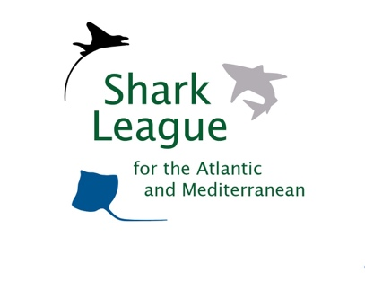
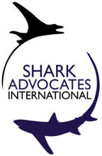

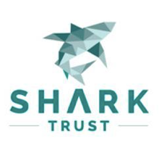
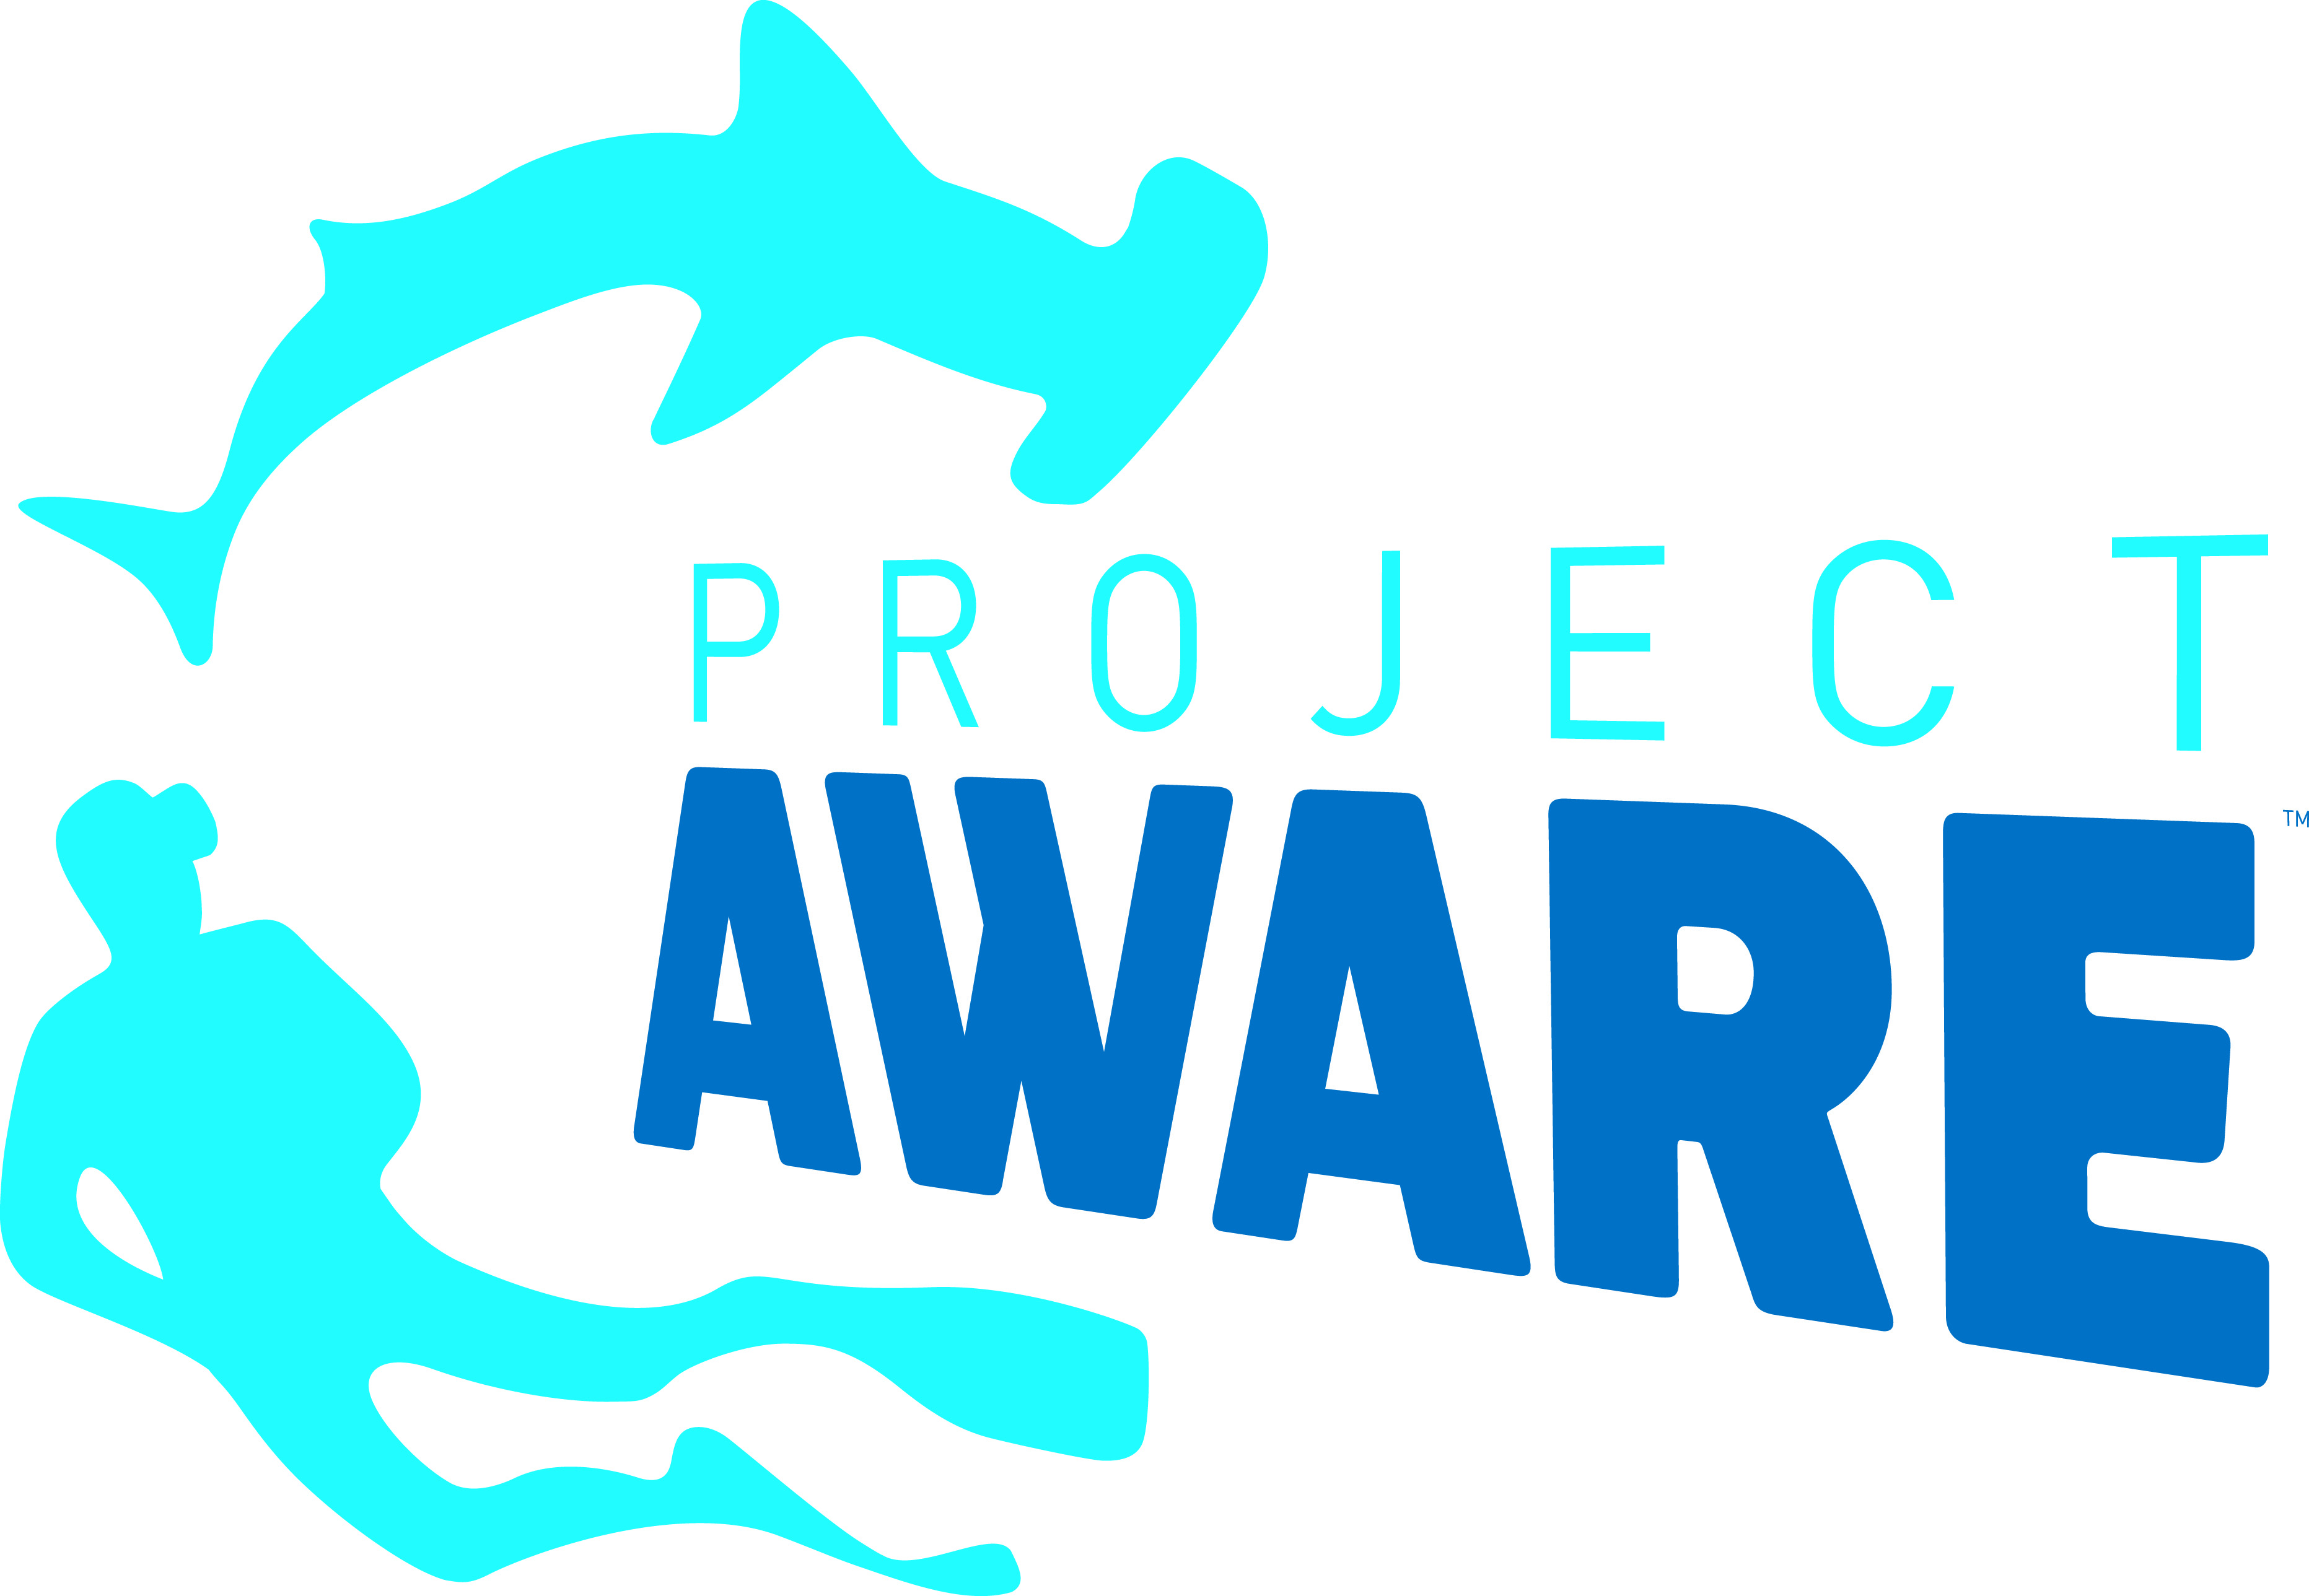
PRESS
RELEASE

Targeting Arctic Shark Banned by North Atlantic Fishery Managers
International Fisheries Commission takes action for exceptionally long-lived Greenland Sharks and depleted Thorny Skates, but falls short of scientific advice

Tallinn, Estonia. September 21, 2018. Fishery managers have taken conservation action for the Greenland shark – the species thought to have the longest lifespan of any vertebrate. At their annual meeting, member countries of the Northwest Atlantic Fisheries Organization (NAFO) agreed a ban on intentional take of Greenland sharks from international waters, along with other requirements for all NAFO countries to maximize live release of accidental catches and minimize associated harm. Scientists had recommended a complete ban on retention and landing of the species, action that was supported by conservationists and proposed jointly by the EU and US. ©

“We are pleased that NAFO has taken an important first step toward protecting Greenland Sharks yet still disappointed that the new ban falls short of the scientific advice, particularly given the vulnerability of this exceptionally long-lived species,” said Sonja Fordham, president of Shark Advocates International. “We urge individual fishing nations to go further than NAFO and fully protect Greenland sharks in their waters.”

Scientists estimate that Greenland Sharks can live roughly 400 years and don’t reproduce until about age 150, leaving populations exceptionally susceptible to overfishing. Following a two-year study, NAFO scientists recommended a suite of measures to protect and better understand Greenland sharks. The joint EU-US proposal to ban all retention was met with opposition from Denmark on behalf of Faroe Islands and Greenland. Iceland and Norway also raised concerns.
NAFO also adopted new requirements for collecting data on each Greenland shark caught, directed investigation into times and places where incidental catch is high, and requested advice on additional conservation measures for their 2021 meeting.
“It’s good to see fishing countries recognize the pressing need for more information on deep-sea shark catches,” said Shannon Arnold, marine policy coordinator for Ecology Action Centre. “Additional conservation actions should not, however, be endlessly delayed while waiting for more data. New information must feed promptly into concrete measures that change fishing practices in a way that minimizes harm to Greenland Sharks.”
The coalition encourages scientists, managers, fishers, tourists, and divers to help improve understanding of Greenland shark status by researching and sharing information about interactions, biology, products, and trade.
For Thorny Skate fisheries, NAFO renewed a 7,000t catch limit although NAFO scientists recommend catches not exceed ~4,000t. This targeted species is not recovering well from past overfishing despite more than a decade of NAFO management.

"We are deeply disappointed that no NAFO Parties stepped up as champions for aligning Thorny Skate catch limits with those advised by scientists,” said Ali Hood, Director of Conservation for the Shark Trust. “As a result, this vulnerable species remains at risk for further depletion."
Media Contact:
…
Shark Advocates International is a project of The Ocean Foundation dedicated to securing science-based policies for sharks and rays. Ecology Action Centre promotes sustainable, ocean-based livelihoods, and marine conservation in Atlantic Canada. The Shark Trust is a UK charity working to safeguard the future of sharks through positive change. Focused on sharks in peril and marine debris, Project AWARE is a growing movement of scuba divers protecting the ocean planet – one dive at a time. These groups have formed the Shark League (www.sharkleague.org).

NAFO Contracting Parties include Canada, Cuba, Denmark (in respect to the Faroe Islands and Greenland), the European Union, France (in respect to Saint Pierre et Miquelon), Iceland, Japan, Republic of Korea, Norway, Russian Federation, Ukraine, and the US. NAFO Parties develop international management measures for Northwest Atlantic fish (except salmon, tunas/marlins, and sedentary species).

