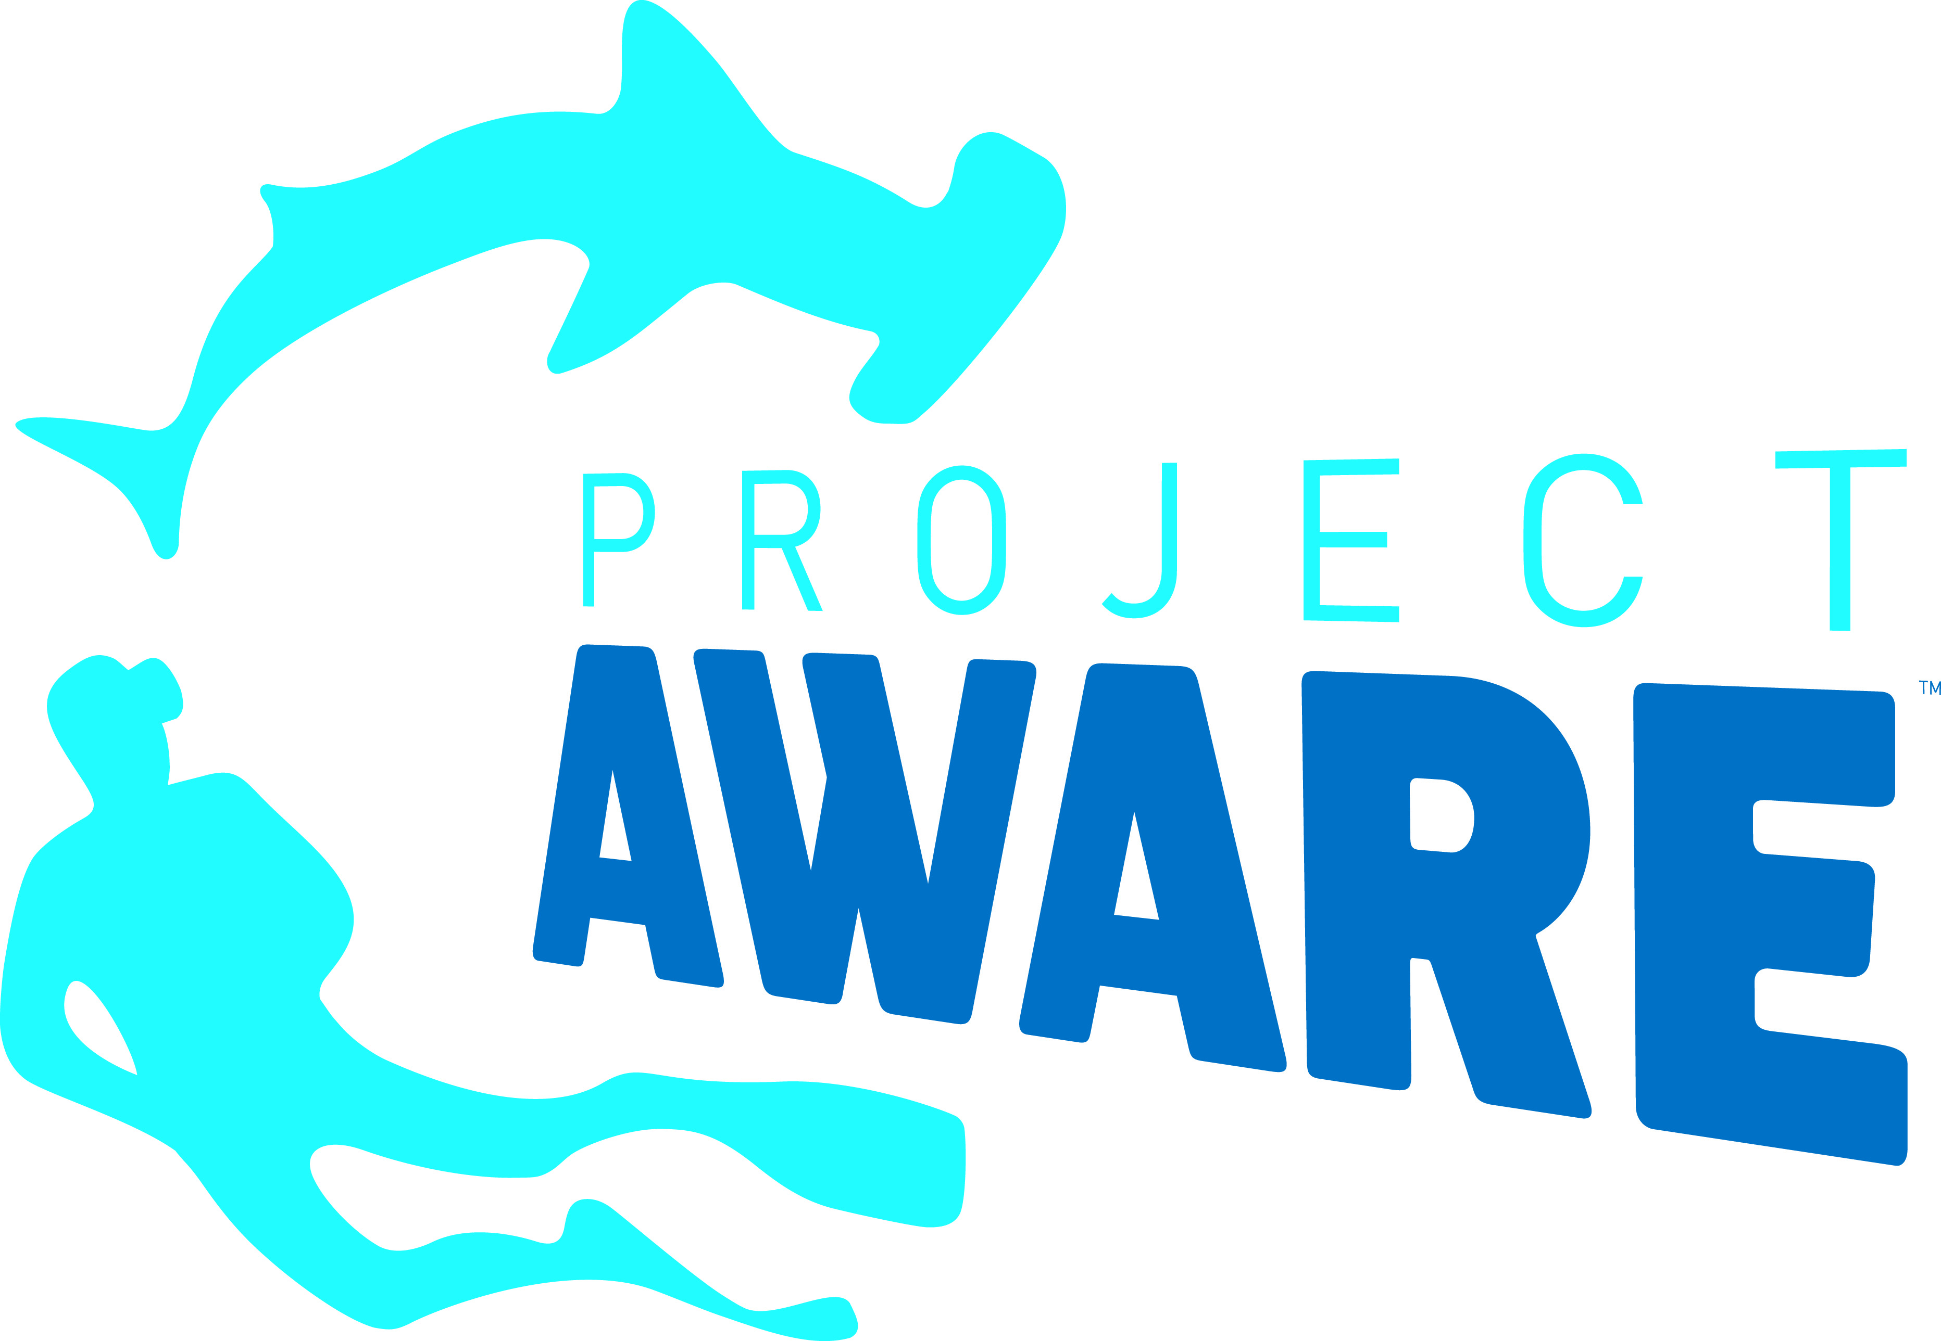
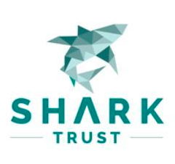
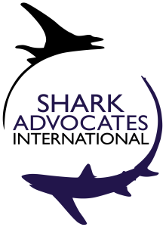

PRESS RELEASE

Endangered Devil Ray Landings in Turkey Denounced
Conservation Groups Call On Mediterranean Officials to Better Enforce Protections

London, UK. March 15, 2017. Conservation groups are calling for answers and action in relation to the landing in Turkey of 30 Giant Devil Rays in contravention of Mediterranean agreements to protect the Endangered species. The groups are asking Turkish and regional fisheries authorities about the national gaps that allowed the take, and the regulatory steps that will be taken to prevent a reoccurrence.

“This egregious take of exceptionally vulnerable Giant Devil Rays flies in the face of multiple well-founded policies aimed at strictly protecting the species,” said Sonja Fordham, President of Shark Advocates International, a project of The Ocean Foundation. “Governments worldwide have agreed to safeguard this and closely related rays through several international treaties, but it’s fair to say that the devil is in the details -- or, more specifically, in how individual countries live up to such commitments.”

According to March 11 Turkish news reports, fishermen caught the rays unexpectedly and landed them in the port of Izmir with plans to export the meat to Greece. Under a 2012 measure adopted by the General Fisheries Commission for the Mediterranean (GFCM), however, landing and selling this species is banned. The measure applies to all shark and ray species listed under a special protocol of the Barcelona Convention. Turkey and Greece are Parties to both the GFCM and the Barcelona Convention.

“We are deeply concerned that this blatant ignorance or disregard of binding measures runs counter to GFCM reports that implementation of the 2012 shark and ray measure has progressed well, including in Turkey and Greece,” said Ali Hood, Conservation Director for the Shark Trust. “We will press both Turkish Authorities and the GFCM to immediately address troubling gaps, as part of an ongoing campaign to ensure compliance with the measures that are essential for the recovery of the Mediterranean’s beleaguered sharks and rays.”

All nine Devil Ray species are listed under Appendix I & II of the Convention on Migratory Species (CMS) as well as Appendix II of the Convention on International Trade in Endangered Species (CITES). Species on CMS Appendix I are meant to be strictly protected. New CITES obligations to track and restrict international Devil Ray trade to sustainable levels take effect April 4, 2017. Greece is a Party to both of these global treaties while Turkey is a member of CITES, but not CMS.

“Divers are especially fond of Devil and closely related Manta Rays, and we have fought hard to win them protections under wildlife treaties,” noted Ania Budziak, Associate Director for Project AWARE. “We are especially eager to see the CITES listings come into force in the coming weeks, as they are key to preventing Devil Ray trade from contributing to further population declines, and could help to remove the incentive to land rays that are caught incidentally in fisheries targeting other species.”

The conservation groups are also looking to a June GFCM Compliance Meeting and a new IUCN Global Conservation Strategy for Devil and Manta Rays as key avenues for addressing policy deficiencies.

Media contact: Sophie Hulme, email: sophie@communicationsinc.co.uk; tel: +447973712869.

Notes to Editors:
Shark Advocates International is a project of The Ocean Foundation dedicated to science-based conservation of sharks and rays. The Shark Trust is a UK charity working to safeguard the future of sharks through positive change. Focused on sharks in peril and marine debris, Project AWARE is a growing movement of scuba divers protecting the ocean planet – one dive at a time. Together with the Ecology Action Centre, the groups collaborate toward ending overexploitation of sharks and rays in the Mediterranean and Atlantic.

Devil Rays give birth to just one pup every one to three years, leaving them particularly susceptible to overfishing. The Giant Devil Ray (Mobula mobular) of the Mediterranean is classified as Endangered on the IUCN Red List of Threatened Species.

The new IUCN Global Conservation Strategy for Devil and Manta Rays is available at: https://peerj.com/articles/3027/

Under GFCM/36/2012/3, Shark and ray species listed under Annex II of the Barcelona Convention Protocol concerning the Specially Protected Areas and Biological Diversity in the Mediterranean (including M. mobular) “cannot be retained on board, transhipped, landed, transferred, stored, sold or displayed or offered for sale.” Instead, these species “must be released unharmed and alive to the extent possible,” and ensured “a high protection from fishing activities” by GFCM Contracting Parties and Cooperating non-contracting Parties.

