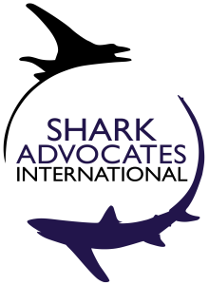
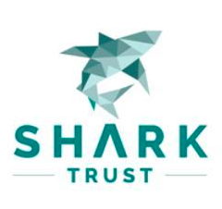
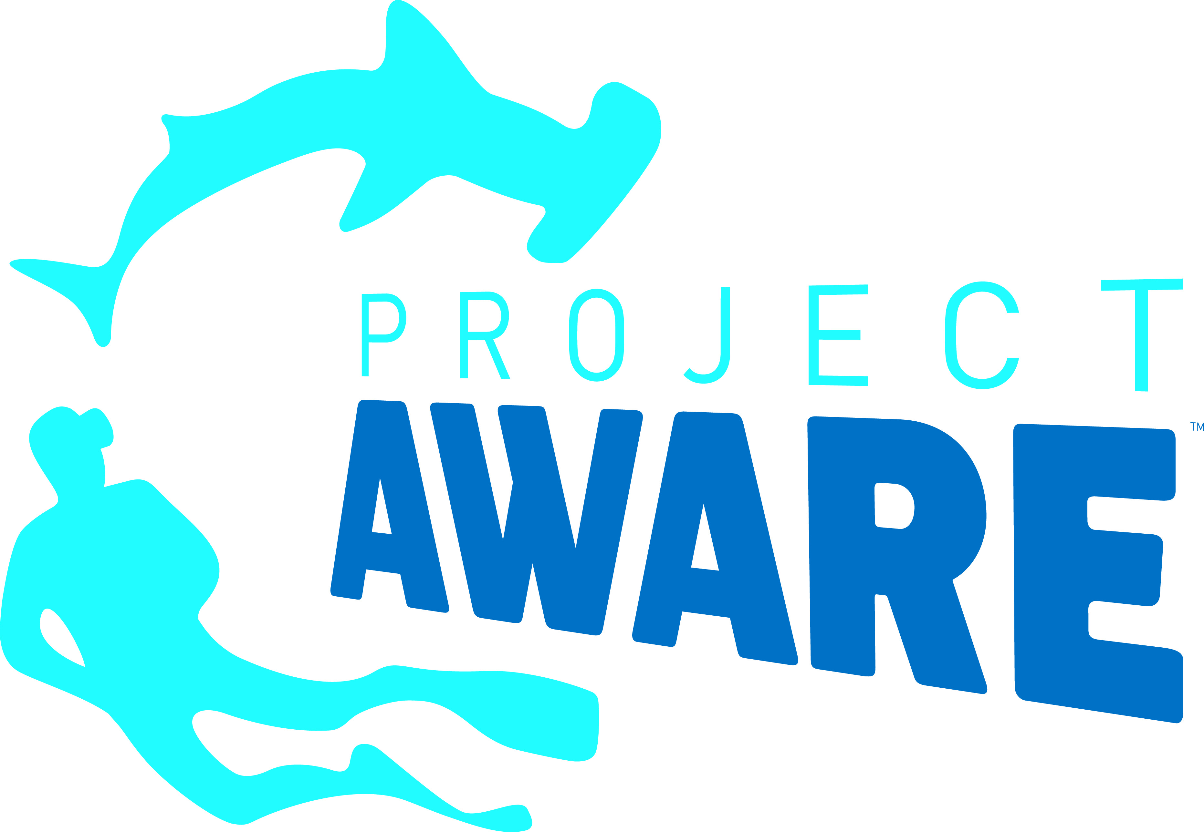
PRESS RELEASE

Contact: Liz Morley, +1 (843) 693-5044
info@sharkadvocates.org

Twenty-two Shark and Ray Species Added to Scope of Global Agreement
New commitments and partners agreed by Signatories to Convention on Migratory Species Shark MoU

San Jose, Costa Rica. February 19, 2016. Signatories to the Convention on Migratory Species (CMS) Memorandum of Understanding (MoU) for Sharks have unanimously agreed to add twenty-two species of sharks and rays to the MoU scope, and to accept the applications of six conservation groups as Cooperating Partners in fulfilling MoU objectives. Conservationists are, in turn, calling on countries to take concrete national and international actions to fulfill new commitments to the imperiled species.

The CMS 2010 Shark MoU is the first global instrument dedicated to the conservation of migratory sharks and rays. The addition of 22 species (listed on the CMS Appendices in 2011 and 2014) brings the total number of species under the MoU’s scope to 29: white shark, porbeagle, spiny dogfish, basking shark, both makos, all three threshers, two species of hammerheads, whale shark, all nine devil rays, both mantas, all five sawfishes, and the silky shark. The number of MoU Signatories rose to 40 (39 national governments and the EU) with this week’s addition of Portugal.

“We are encouraged by the growing number of countries that are engaging in CMS shark and ray conservation activities, and welcome the expansion of the Shark MoU scope,” said Sonja Fordham of Shark Advocates International. “At the same time, we are eager for countries to follow up with concrete actions in line with these commitments, particularly strict protections for highly threatened rays, and fishing limits to ensure the long-term health of migratory shark populations.”

Through the CMS Shark MoU and associated Conservation Plan, signatories have agreed to facilitate a better understanding of shark populations and fisheries, set science-based catch limits, prevent “finning” (slicing off a shark’s fins and discarding the body at sea), protect critical shark habitats, and cooperate toward shark conservation through international fisheries and wildlife bodies. Shark Advocates International, Shark Trust, and Project AWARE were among the conservation groups accepted as Cooperating Partners in fulfilling Sharks MoU objectives.

“Our organizations are honored by the opportunity to serve as Cooperating Partners and thereby collaborate toward migratory shark and ray conservation with countries at the forefront of this critical work,” said Ali Hood, Director of Conservation for the Shark Trust. “This status gives us a special opportunity to share expertise and provide support while ensuring implementation of the associated Conservation Plan."

CMS Parties are obligated to strictly protect the manta and devil rays and the five sawfishes (through listing on CMS Appendix I), and to work internationally to conserve the sharks listed on Appendix II.

“We applaud Costa Rica for hosting this important and successful meeting, and for the country’s past initiatives to secure international trade controls on hammerheads and to strengthen shark finning bans on a global scale,” said Ania Budziak, Associate Director for Project AWARE. “We are hopeful that new commitments made this week will lead to strict national protections for devil rays and sawfishes, and the end of Costa Rican opposition to regional fishing limits for hammerhead and silky sharks.”

Notes to Editors:

The groups outlined specific requests for action in a document distributed at the meeting: http://www.sharkadvocates.org/pdf/conserving_migratory_sharks_2-16.pdf

The CMS meeting coincided with the release of a new global strategy from a coalition of conservation groups including Shark Advocates International and Shark Trust. See: http://www.sharktrust.org/en/global_strategy

Shark Advocates International is a project of The Ocean Foundation working to safeguard sharks and rays through sound, science-based conservation policy. www.sharkadvocates.org

The Shark Trust is a UK charity working to advance the worldwide conservation of sharks through science, education, influence and action. www.sharktrust.org

Project AWARE is a growing movement of scuba divers protecting the ocean planet – one dive at a time. www.projectaware.org

The Convention on Migratory Species of Wild Animals (CMS) is an intergovernmental treaty formed under the United Nations Environment Program. http://www.cms.int/. With 122 member governments, CMS works for the regional and global conservation of a variety of threatened migratory animals through negotiation and implementation of agreements and action plans. CMS activities and instruments are open to non-Parties. More about the CMS Shark MoU here: http://www.cms.int/sharks/

