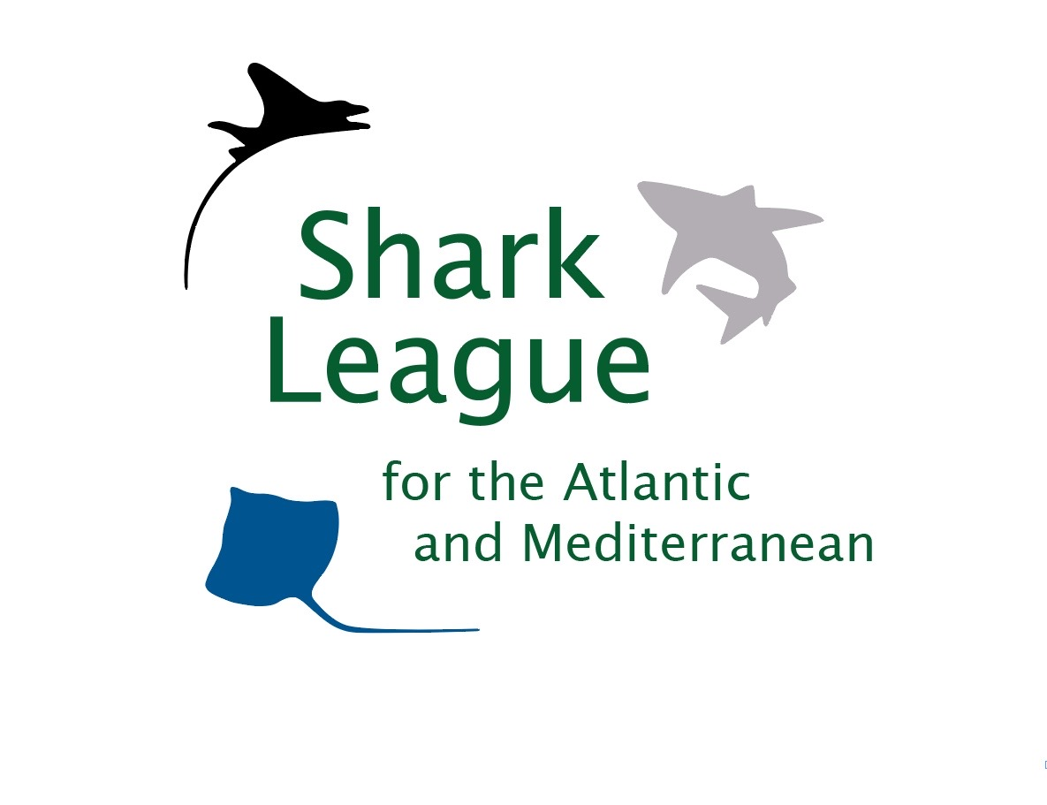
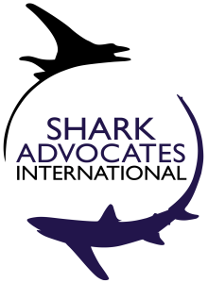
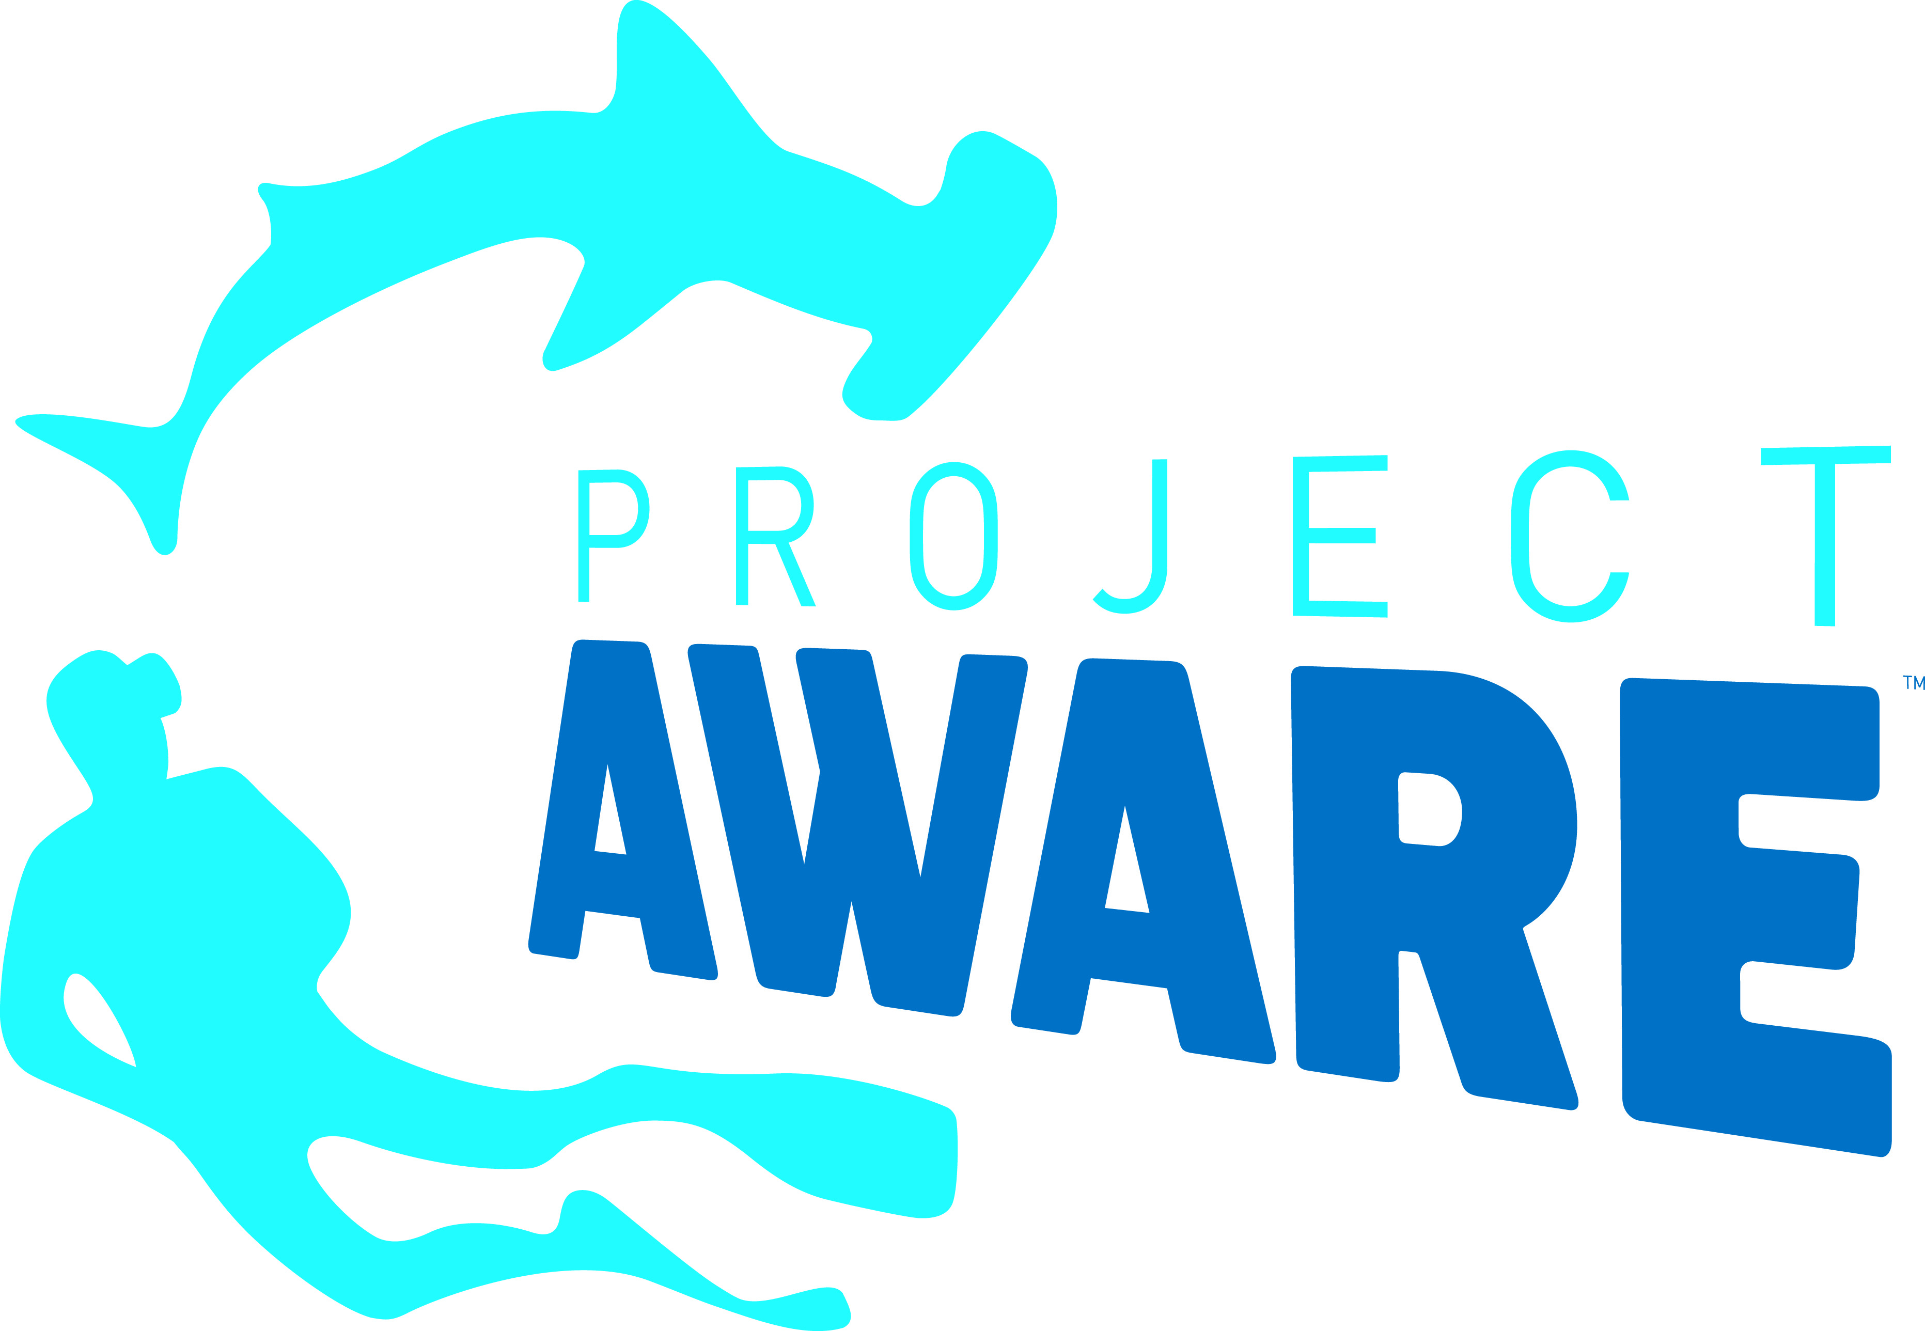
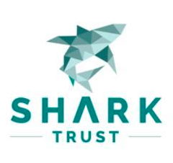

PRESS
RELEASE

EU Holds the Cards for Endangered Atlantic Sharks
It’s make or break time for shortfin makos as Spain sets to host international fisheries meeting

London, November 2019. Conservationists are focused on the European Union ahead of an international gathering of fishing nations that could make or break the future of Endangered mako sharks. The International Commission for the Conservation of Atlantic Tunas (ICCAT) will consider sobering new scientific advice about the status of shortfin makos at its annual meeting, November 18-25 in Mallorca. To reverse decline of the seriously overfished North Atlantic population, scientists are advising that ICCAT completely ban fishermen from retaining catches. There are no EU or ICCAT fishing quotas for makos. The EU ranks first in the world for mako landings, primarily because of vessels from Spain.

“The conservation status of North Atlantic shortfin mako sharks is atrocious, and the EU is mostly to blame,” said Ali Hood, Director of Conservation for the Shark Trust. “Spanish fleets have consistently, year in and year out, taken more makos than any other country. All the while, the EU has ignored countless warnings about overfishing and has failed to even limit the amount of makos that can be landed. The result, unsurprisingly, is disaster. This ICCAT meeting presents a critical juncture for EU fisheries managers. It is time to finally put an end to reckless mako fishing policies and begin leading ICCAT toward adopting the clear and urgent scientific advice.”

The shortfin mako is one of the world’s most economically valuable sharks, sought for meat, fins, and sport. Their slow growth makes them exceptionally vulnerable to overfishing. Depletion of this highly migratory, oceanic species is most apparent in the North Atlantic. Based on new analyses, ICCAT scientists are warning that annual North Atlantic shortfin mako catches need to be cut from recent levels (~3000 metric tons) to just ~300t to give the population a decent (60%) chance of recovering within five decades. Their decision to recommend a complete ban for this population takes into account mortality from incidental catches.

In March 2019, the International Union for the Conservation of Nature (IUCN) classified shortfin (and longfin) mako sharks as Endangered, based on Red List criteria. In August, the EU and 27 co-sponsors successfully proposed both species for listing on Appendix II of the Convention on International Trade in Endangered Species (CITES). By late November, CITES Parties (including all ICCAT Parties) will be required to demonstrate that mako exports are sourced from legal, sustainable fisheries.

“Just a few months ago, the EU took to the world stage to help secure global conservation commitments for makos under CITES, but the EU’s efforts to ensure that these obligations are implemented through fisheries restrictions are to date lacking, “said Sonja Fordham, President of Shark Advocates International. “We are hopeful that 2019 will continue to be a pivotal year for mako shark conservation, but true progress where it matters most now – at ICCAT – depends on the EU stepping up and fighting for the mako ban that scientists advise. Such action is needed to save this valuable shark population from complete collapse. It’s truly make or break time.”

Media contact: Patricia Roy email: patricia@communicationsinc.co.uk, Tel: +34 696 905 907.

Shark Advocates International is a project of The Ocean Foundation dedicated to securing science-based policies for sharks and rays. The Shark Trust is a UK charity working to safeguard the future of sharks through positive change. Focused on sharks in peril and marine debris, Project AWARE is a global movement for ocean protection powered by a community of adventurers. Ecology Action Centre promotes sustainable, ocean-based livelihoods, and marine conservation in Canada and internationally. These groups, with support from the Shark Conservation Fund, formed the Shark League of the Atlantic and Mediterranean to advance responsible regional shark and ray conservation policies (www.sharkleague.org).

